
Computers & Industrial Engineering 209 (2025)
Contents lists available at ScienceDirect

Computers & Industrial Engineering

journal homepage: www.elsevier.com/locate/caie



Predicting Flight Cancellations, Cancellation Causes and Departure Delays from Historical, Meteorological and Same-Day Operational Data, with a Smart Ticketing Prototype
Eda Nur Mutlu ª, Nuri Can Birdemir ª, Eyüp Emre Ülkü ª

ª Marmara University, Faculty of Technology, Turkey

A R T I C L E I N F O

Keywords:
Flight delay and cancellation prediction
Explainable AI (XAI)
XGBoost and SHAP values
Meteorological data integration
Imbalanced data classification
Air transportation analytics
Smart ticketing system
Web-based decision support
A B S T R A C T

Flight cancellations and delays burden passengers and airlines, yet published predictors are often evaluated after resampling, with leaked features or by accuracy on imbalanced targets, which hides weak performance. We predict three separate outcomes on 3.58 million U.S. domestic flights (January 2019 to August 2023 and January 2024): flight cancellation, cancellation cause (carrier, weather, national air system) and four-class departure delay. XGBoost models use calendar and schedule data, weather observed on the previous day (Meteostat), recent cancellation and delay rates and, in an optional day-of-departure mode, the operational state three hours before departure. Training (2019-01 to 2022-06) is followed by random-search tuning and threshold selection (2022-07 to 2022-12) and a single test on 2023-01 to 2023-08 and 2024-01 with the natural class distribution; the final models use no resampling. Cancellation PR-AUC was 0.119 (ROC-AUC 0.800) with previous-day information and 0.196 (0.857) with same-day state, against a no-skill level of 0.029. Cause accuracy was 70.7% and 73.9% (majority baseline 60.2%); four-class delay accuracy was 60.8% and 61.9% (baseline 60.0%), with ROC-AUC 0.693 and 0.721 for delays beyond 15 minutes. Ablations show that recent operational history, not weather, drives most of the gain, and performance varies strongly between months. SHAP identifies airline-level cancellation rates as the main cancellation predictors. Cancellation alerts pay off only when a missed cancellation costs about ten or more times a false alarm, so the models are risk indicators, not precise forecasts. A prototype, SmartTicket, shows them in ticket search; its user validation remains future work.

Introduction

Although air transport is a rapidly growing industry, flight delays and cancellations remain one of its most significant problems. They reduce passenger satisfaction and cause economic losses for airlines and airports through operational disruptions; furthermore, delays propagate through the network, leading to chain delays and complicating airspace management (Li & Yao, 2025).
According to the U.S. Department of Transportation, 78.34% of the flights of reporting carriers arrived on time in 2023 (that is, within 15 minutes of the schedule), and the ten largest airlines cancelled 1.29% of their flights (U.S. Department of Transportation, 2024). The problem is not limited to the United States: according to the punctuality statistics of the UK Civil Aviation Authority, only 54.8% of the flights at London Gatwick were on time in 2023 (from early to at most 15 minutes late), the lowest share among the reporting UK airports, with an average delay of 27.5 minutes (Civil Aviation Authority, 2024), and a passenger-rights company estimated that more than 45 million passengers travelling from the UK were affected by delays or cancellations (AirHelp, 2024).
Many published predictors, however, are evaluated with random splits or after resampling the whole data set, use information that becomes known only after departure, or report overall accuracy on strongly imbalanced targets, which hides weak performance on the rare classes (Section 2). This study addresses these limitations for three related prediction tasks on a rebuilt data set of U.S. domestic flights: (i) flight cancellation (binary), (ii) cancellation cause (carrier, weather, national air system) for cancelled flights and (iii) departure-delay class for operated flights. All models are validated chronologically on the natural class distribution.
The models use calendar and schedule information, the weather observed at the origin and destination airports on the last completed day before the flight (D-1; Meteostat) and the cancellation and delay rates of the preceding days. Same-day daily weather aggregates are not used, because they are known only after the day has ended and would leak future information into predictions for morning flights; the models are therefore risk indicators based on recent observations, not weather forecasts. Two operating modes are distinguished: the advance mode (Mode A) uses information up to D-1 and is the only valid mode for tickets booked in advance, whereas the day-of-departure mode (Mode B) additionally uses the operational state observed three hours before the scheduled departure and requires a live operational data feed.
The study addresses four research questions. RQ1: how well can cancellations, cancellation causes and delay classes be predicted from information available before departure when models are validated chronologically on the natural class distribution? RQ2: how much do previous-day weather, recent operational history and same-day state add to a calendar-and-schedule baseline (ablation study)? RQ3: how do imbalance-handling strategies (none, class weighting, train-only SMOTE-NC) compare? RQ4: which inputs drive the predictions (SHAP), and how stable is performance over time?

* Corresponding author at: Marmara University, Faculty of Technology, RTE Campus, Maltepe, Istanbul, Türkiye.
E-mail addresses: emre.ulku@marmara.edu.tr (E. E. Ülkü).

The main contributions are: (1) a reconstructed and de-duplicated data set of 3.58 million flights with the natural cancellation prevalence - cancelled-only records are deliberately not added because they distort the prior probability of cancellation; (2) a leakage-controlled feature design with automated look-ahead tests; (3) a chronological train/validation/test protocol in which model selection and decision thresholds are fixed before the test period is used once; (4) a joint evaluation of cancellations, their causes and departure delays with class-sensitive metrics, bootstrap confidence intervals, monthly stability and a transparent relative-cost analysis; (5) ablation and SHAP analyses that measure, rather than assume, the contribution of previous-day weather, recent operational history and same-day state; and (6) a prototype (SmartTicket) that connects the models to a ticket-search interface.
Machine learning methods are well suited to extracting information from large and complex data sets (L'Heureux, Grolinger, Elyamany & Capretz, 2017). We use gradient-boosted decision trees (XGBoost; Chen & Guestrin, 2016), which handle mixed numeric and categorical inputs and missing values and are competitive on tabular data (Bentéjac, Csörgő & Martínez-Muñoz, 2021); logistic regression, a decision tree, a random forest and histogram-based gradient boosting are evaluated under the same protocol for comparison. In the prototype the predictions are shown to passengers as a risk indication during flight selection. Further uses for passengers, airlines and airport operators - such as alternative-flight suggestions, delay-aware pricing or resource planning - are potential applications that are neither implemented nor evaluated in this study. The findings are limited to U.S. domestic flights and to the periods covered by the data.
The remainder of the article is organised as follows. Section 2 reviews related work and states the research gap. Section 3 describes the data, the meteorological integration, the features and the models. Section 4 reports the results, including the ablation, SHAP and cost analyses, and describes the SmartTicket prototype. Section 5 discusses the findings and their limitations, and Section 6 concludes.

Literature review

Today, the rapidly increasing demand for air transportation has made the analysis of flight delays an important area of research (Çalış, Durmaz & Gencer, 2018). Researchers widely utilize machine learning and data mining techniques to predict flight delays. Studies in the literature have generally focused on factors such as the location of airport facilities, weather and airport capacity. Machine learning techniques make significant contributions in this field by enabling the storage and processing of large-scale data sets (Sternberg et al., 2017). However, most of the existing research has focused on a specific geographical region or a limited number of factors, and has been lacking in the development of holistic approaches to delay prediction.
This study aims to provide a transparent perspective on forecasting models for flight delays and cancellations. Flight data are combined with meteorological observations from Meteostat. The role of weather is sometimes assumed rather than measured; we therefore quantify the contribution of weather explicitly in an ablation study.
Class imbalance is a well-known difficulty when delays and cancellations are rare events (He & Garcia, 2009). Chawla et al. (2002) introduced SMOTE, which creates synthetic minority examples by interpolation, together with its variant SMOTE-NC for mixed numeric and categorical features. We compare no balancing, class weighting and SMOTE-NC applied strictly inside the training period (see the imbalance-handling comparison in the Results section).
In their study, Khaksar and Sheikholeslami apply various machine learning algorithms to predict airline delays (Khaksar & Sheikholeslami, 2019). Methods such as Decision Trees, Random Forest, Clustering and Bayesian classification were tested on the data obtained from the US and Iran flight networks and focused on predicting the causes of delays more accurately. In the US network, visibility and wind speed have a significant impact on delays, whereas in the Iranian network, factors such as fleet age and aircraft type stand out. A hybrid classification combining Decision Trees and Clustering achieved the highest accuracy, 71.39% on the US network and 76.44% on the Iranian network.
Ye et al. propose a methodology using supervised learning methods to predict flight delays at airports (Ye, Liu, Tian & Wan, 2020). In the study, operational flight data and weather information from Nanjing Lukou International Airport were processed and four types of airport-related features were generated for the prediction models. The study achieved high accuracy, especially in 1-hour delay forecasts, and the LightGBM model gave the best results with an accuracy of 86.55%. The results of this model emphasize the importance of forecasting based on operational and weather conditions. In a similar study, Atlıoğlu et al. evaluated 11 different machine learning models using an operational dataset obtained from a leading airline in Turkey (Atlıoğlu, Bolat, Şahin, Tunalı & Kılınç, 2020). By comparing various performance metrics for each model, the authors tried to identify the most appropriate features in the dataset to achieve the highest accuracy.
Mohamed, Al-Tabbakh and El-Zahed applied various machine learning techniques to analyze flight delay data of EgyptAir (Mohamed, Al-Tabbakh & El-Zahed, 2018). The main objective of the study was to determine the most appropriate classification algorithm for predicting flight delays. The researchers followed a methodology that included data preparation, using classification algorithms and evaluating model performance. Decision-tree and rule-based classifiers (including REPTree, PART, Decision Table, OneR and JRip) were compared in the WEKA data mining tool. The performance of the classification models was evaluated using accuracy, precision, recall, F1-score and ROC area metrics. According to the results of the analysis, the PART algorithm had the highest performance with an accuracy of 83.1%. On the other hand, the REPTree algorithm was identified as the leading tree-based classifier with an accuracy of 80.3% and the fastest running time. The study demonstrated the effectiveness of machine learning techniques in flight delay prediction and provided EgyptAir with important information to improve flight operations. The researchers plan to apply big data mining technologies using larger datasets in the future.
Kurt's study aims to predict flight delays using US domestic flight data (Kurt, 2019). For this purpose, various machine learning methods such as Decision Trees, Random Forest, Bagging, Extra Trees, Gradient Boosting and XGBoost classifier were tested. In the study, where these models were evaluated with success criteria such as accuracy, F1 score and recall, the highest accuracy rate was achieved by the Gradient Boosting algorithm with 71.72%. The study suggests that the prediction performance can be improved by incorporating different data features into the model.
In Tang's study, seven different classification algorithms were evaluated to predict flight delays using one-year data of flights departing from New York JFK Airport (Tang, 2021). Among these algorithms, Decision Tree achieved the highest success with an accuracy rate of 97.78%. In particular, Random Forest and Gradient Boosting methods, which are tree-based classifiers, were found to perform better than other basic classifiers. In the study, it was stated that the unbalanced distribution of the data was eliminated by measures such as weighted accuracy.
Li et al. proposed a CNN-LSTM framework for flight delay prediction in which a convolutional network extracts spatial correlations between airports, an LSTM models their temporal dynamics and a random forest classifier makes the final prediction from these outputs combined with extrinsic features such as airline, distance and scheduled flight time; on 2019 U.S. domestic flight data of the Bureau of Transportation Statistics the model reached an accuracy of 92.39% (Li, Guan & Liu, 2023).
Khan et al. proposed a parallel-series model with an adaptive bidirectional extreme learning machine (AB-ELM) to predict IATA-coded flight delay categories and to analyse their causes, using historical records of a Hong Kong-based international airline (airport, flight, aircraft, weather and delay information) and fourteen sampling methods against imbalanced and noisy data; AB-ELM reached an accuracy of 80.66% (Khan et al., 2024).
Lambelho et al. proposed to assess strategic flight schedules at London Heathrow (LHR) airport with machine-learning-based predictions of flight delays and cancellations; the approach was demonstrated on the schedules of 2013-2018 (Lambelho, Mitici, Pickup & Marsden, 2020).
A paper by Truong analyzed flight delay risk with causal machine learning techniques. This study not only focused on prediction accuracy, but also conceptualized the structural causal relationships of the key parameters leading to delay and constructed "cause-and-effect" networks (Truong, 2021).
Table 1 provides a comparative overview of recent and prominent studies on flight cancellation and delay prediction. The machine learning techniques used in each study, the data sources, the problems focused on, and the success rates achieved are analyzed. Thus, the similarities and differences between the prominent approaches in the existing literature and the methods used in this project are more clearly revealed.
Table 1
Comparative Literature Table: Flight Cancellation and Delay Forecasting Studies.
Study | Method / Algorithm | Advantages | Disadvantages | Performance / Results
Khaksar & Sheikholeslami (2019) | Decision Trees, RF, Clustering | Comparison of US/Iran networks - Factor diversity | Weak multi-model framework | Hybrid method: 71.39% (US) and 76.44% (Iran) accuracy; wind (US) and fleet age (Iran) decisive
Ye et al. (2020) | LightGBM | 4 feature groups created - 1-hour predictions successful | Single airport (Nanjing) focused | Accuracy: 86.55%
Atlıoğlu et al. (2020) | 11 different ML models | Model comparisons made - Focused on feature extraction | Model names and results not detailed | Optimal model selection made
Mohamed et al. (2018) | Decision-tree and rule-based classifiers (WEKA) | Comparison of several classifiers - metrics such as ROC, F1 used | Limited to Egyptian data only | PART: 83.1%, REPTree: 80.3% accuracy
Kurt (2019) | RF, XGBoost, Bagging, GBM | Experiment with US domestic data - detailed F1 and recall measures | Accuracy is relatively low | The best: Gradient Boosting 71.72%
Tang (2021) | 7 different algorithms | Promotion of tree-based models - Data imbalance-weighted solution | Single airport (JFK) data | Decision Tree: 97.78% accuracy
Lambelho et al. (2020) | ML-based delay and cancellation predictors | Heathrow data - delays and cancellations assessed together for strategic schedules | Model details limited | Schedule-assessment method; no accuracy figure quoted here
Khan et al. (2024) | Parallel-series model with AB-ELM | Joint prediction of IATA-coded delay categories and their causes - 14 sampling methods compared | Data of a single airline (Hong Kong) | AB-ELM accuracy 80.66%
Truong (2021) | Causal machine learning (USELEI process, causal network) | Causal relationships between operational factors - what-if scenario analysis | Delay risk only (no cancellations) | Significant factors: traffic volume, demand, capacity, efficiency at origin and destination airports
Li et al. (2023) | CNN-LSTM + random forest (spatio-temporal) | Deep learning - models spatial (airport) and temporal correlations | Multi-stage pipeline; U.S. data of a single year | Accuracy 92.39% (2019 U.S. domestic flights)
Note: the performance figures in Table 1 and in the tables of Section 4.5.2 are quoted from the original studies. They are based on different datasets, tasks, class definitions and validation protocols and are not comparable with each other or with the results of this study. Kurt (2019) is a master's project, Giarmas (2025) a university thesis, Ansari et al. (2019) a conference paper deposited on SSRN, the AeroPredict paper (Hake et al., 2025) a short system description in an online engineering journal without reported metrics, and Barua and Kaiser (2024) and Sternberg et al. (2017) arXiv preprints; these are not peer-reviewed journal articles. Chawla et al. (2002) is not a flight-delay study; it introduced SMOTE and is cited only for the oversampling technique.

In recent years, studies that not only model with machine learning but also integrate these models into systems that are open to user interaction have gained importance. In particular, "smart ticketing systems" and web-based artificial intelligence applications have become one of the basic building blocks of decision support systems in the airline industry.
Alfarhood et al. predicted flight delays from five years of domestic Saudi Arabian flight records and weather data (case study: Saudi Arabian Airlines); CatBoost gave the best accuracy for the delayed/on-time classification (76%) and the lowest mean absolute error for the delay duration (12.19 minutes), and the model was made available through a web dashboard for forecasts and analysis (Alfarhood et al., 2024).
Similarly, AeroPredict combines machine-learning predictions of flight disruptions and ticket price changes with a flight-booking interface that personalises the search and sends automated notifications; the authors report improvements over conventional booking platforms in forecast accuracy, user engagement and booking satisfaction but give no quantitative results (Hake et al., 2025).
Barua and Kaiser proposed a cloud-microservice airline reservation system with distributed AI modules (booking history and customer profiles are used to estimate demand and to make recommendations) and a blockchain ledger for transactions; in a simulation-based evaluation they report improvements over conventional systems in availability (30%), scalability (40%), customer engagement (25%) and response time (15%) (Barua & Kaiser, 2024).
These recent examples are similar to our ticketing prototype. Our contribution lies mainly in the leakage-controlled evaluation of the underlying models; the prototype itself has not yet been evaluated in a user study.
Table 2 compares these studies with the SmartTicket prototype in terms of the methods used, their advantages and disadvantages and the reported results.
Table 2
Comparative Literature Table: Smart Airfare Ticketing Systems.
Study | Methods Used | Advantages | Disadvantages | Performance / Results
Alfarhood et al. (2024) | ML-based delay prediction (CatBoost best) + web dashboard | Delay classification and duration - dashboard with forecasts and analysis | Delay only (no cancellation); domestic Saudi data | CatBoost accuracy 76%, MAE 12.19 min
Hake et al. (2025, AeroPredict) | ML models (not specified) + web booking interface | Flight search and disruption/price forecasts integrated - automated notifications | Algorithm, data and metrics not reported | No quantitative results reported
Barua & Kaiser (2024) | AI modules + cloud microservices + blockchain | Modular reservation architecture - secure transactions - recommendation modules | Simulation-based evaluation; complex architecture; no flight-delay model | Availability +30%, scalability +40%, engagement +25%, response time +15% (simulation)
SmartTicket | XGBoost + Multi-tier system (Model API + Backend + Frontend) | Multiple models including cancellation, delay and reason for cancellation - Relative risk + detail panel - Model insights via UI | Resource requirements may increase in case of full integration in real data | Cancellation test ROC-AUC 0.80 (Mode A) / 0.86 (Mode B); delay classes only marginally above the majority baseline; no user study yet

This study combines flight, weather and operational-history information with a strict chronological evaluation protocol. Considering the limitations of existing studies, it is expected to provide a transparent baseline for future research.
This review is a narrative, non-exhaustive survey of studies published between 2018 and 2024 on machine-learning approaches to flight cancellation, delay and smart ticketing; no formal systematic-review protocol (search strings, inclusion and exclusion criteria) was applied. Among the studies we examined, most focus on a single airline or airport, make limited use of meteorological data, and report overall accuracy without chronological validation or class-sensitive metrics. Quoted accuracy values come from different datasets, prediction tasks, class definitions and validation protocols and must not be compared with each other directly.
In this study the prediction inputs are: calendar and schedule features, airline, origin, destination and distance, weather observed on the previous day at the origin and destination airport, cancellation and delay rates of the preceding day and week (nation-wide, per origin airport and per airline) and, in Mode B, the operational state of the same day observed three hours before departure. Aircraft type and flight density were not available in the data and are not used. Instead of a binary delay label, delays are predicted in minute classes (<=0, 1-15, 16-30 and >30 minutes), and the probability of each class is returned.
Flight data are integrated with daily weather observations from Meteostat (see the meteorological data integration subsection). Class imbalance is addressed by comparing no balancing, class weighting and train-only SMOTE-NC; the final models use no resampling because it did not improve validation PR-AUC (see the imbalance-handling comparison in the Results section).
The research gap addressed here is methodological. Many studies evaluate with random splits or after resampling the whole data set, use same-day weather aggregates for early-morning flights, or report overall accuracy on strongly imbalanced targets. We provide a leakage-controlled, chronologically validated comparison for three related tasks, with class-sensitive metrics, ablations and an explicit statement of what the models can and cannot do.

Dataset and models

This section describes the dataset, the meteorological integration, the feature design and the supervised learning models. The data were rebuilt from the original public sources, and the processing order is designed so that no information from the evaluation period influences training, feature construction or model selection.
The dataset is based on the U.S. Department of Transportation (DOT) / Bureau of Transportation Statistics on-time performance records and contains flight routes, scheduled and actual times and cancellation codes. Two open sources are used (Table 3). (1) The Zelaya data set (Zelaya, 2023) is a random sample of 3,000,000 flights from January 2019 to August 2023 with the natural proportion of cancelled flights (it is a sample, not the complete DOT data; 32 columns, Table 4). (2) The Singh data set (Singh, 2024) provides the complete month of January 2024 with 582,425 flights, including non-cancelled flights. The two sources cover different periods; no duplicates were found on the key flight date, DOT carrier identifier, flight number, origin, destination and scheduled departure time. The final data set contains 3,582,425 flights, of which 101,213 (2.83%) were cancelled and 8,693 diverted. Public files that contain only cancelled flights were deliberately not added: inserting such minority-class records raises the share of cancelled flights from about 2-3% to about 9%, distorts the natural prior probability of cancellation and can make the calendar year an almost perfect indicator of the label. All reported results therefore use the natural class distribution. The data are split chronologically (Table 3).
Table 3
Data sources, reconstructed data set and chronological split.
Part | Period | Flights | Cancelled | Cancel. rate
Zelaya sample (source 1) | 2019-01 to 2023-08 | 3,000,000 | 79,140 | 2.64%
Singh (source 2) | 2024-01 | 582,425 | 22,073 | 3.79%
Total | 2019-01 to 2024-01 | 3,582,425 | 101,213 | 2.83%
Training | 2019-01 to 2022-06 | 2,186,925 | 63,786 | 2.92%
Validation | 2022-07 to 2022-12 | 349,591 | 7,545 | 2.16%
Test | 2023-01 to 2023-08, 2024-01 | 1,045,909 | 29,882 | 2.86%
Weather is one of the main external factors that affect the timeliness of flights (Schultz, Reitmann & Alam, 2021); wind speed, temperature, precipitation and snow are among the variables provided by Meteostat. Weather data were obtained from the Meteostat library (Meteostat, 2024), which aggregates ground-station observations into daily values. The weather of the day before the flight (D-1) is attached to each flight, for the origin and the destination airport.
Meteostat provides daily minimum, maximum and mean temperature (°C), precipitation (mm), snow depth (mm), wind direction, average wind speed (km/h), peak gust, sea-level pressure (hPa) and sunshine duration. Wind direction, gust and sunshine duration are missing for more than half of the days and were not used. The remaining seven variables enter the models as D-1 values.

Table 4
Variables of the source flight data (Zelaya, 2023).
 | Updated Title | Source Title | Data Type |  | Description
0 | FL_DATE | FlightDate |  | object | Flight date
1 | AIRLINE | Airline |  | object | Name of the airline
2 | AIRLINE_DOT | AirlineDot |  | object | DOT identifier for airline
3 | AIRLINE_CODE | Reporting_Airline |  | object | Name of the airline
4 | DOT_CODE | DOT_ID_Reporting_Airline |  | int64 | DOT identifier for airline
5 | FL_NUMBER | Flight_Number_Reporting_Airline |  | int64 | Flight number
6 | ORIGIN | Origin |  | object | Departure airport code
7 | ORIGIN_CITY | OriginCityName |  | object | Departure airport city
8 | DEST | Dest |  | object | Destination airport code
9 | DEST_CITY | DestCityName |  | object | City of arrival airport
10 | CRS_DEP_TIME | CRSDepTime |  | int64 | Planned departure time
11 | DEP_TIME | DepTime |  | float64 | Actual departure time
12 | DEP_DELAY | DepDelay |  | float64 | Departure delay
13 | TAXI_OUT | TaxiOut |  | float64 | Time spent taxiing
14 | WHEELS_OFF | WheelsOff |  | float64 | When the wheels of the airplane leave the ground
15 | WHEELS_ON | WheelsOn |  | float64 | When the wheels of the airplane touch the ground
16 | TAXI_IN | TaxiIn |  | float64 | Time spent taxiing
17 | CRS_ARR_TIME | CRSArrTime |  | int64 | Planned arrival time
18 | ARR_TIME | ArrTime |  | float64 | Actual arrival time
19 | ARR_DELAY | ArrDelay |  | float64 | Arrival delay
20 | CANCELLED | Cancelled |  | float64 | Indication of whether the flight has been canceled (1 for canceled, 0 for not canceled)
21 | CANCELLATION_CODE | CancellationCode |  | object | Reason for cancellation (if applicable)
22 | DIVERTED | Diverted |  | float64 | Indication of whether the flight was diverted or not (1 for diverted, 0 for not diverted)
23 | CRS_ELAPSED_TIME | CRSElapsedTime |  | float64 | Planned elapsed time
24 | ELAPSED_TIME | ActualElapsedTime |  | float64 | Actual elapsed time
25 | AIR_TIME | AirTime |  | float64 | Time spent in the air
26 | DISTANCE | Distance |  | float64 | Distance traveled
27 | DELAY_DUE_CARRIER | CarrierDelay |  | float64 | Delay due to carrier
28 | DELAY_DUE_WEATHER | WeatherDelay |  | float64 | Delay due to weather conditions
29 | DELAY_DUE_NAS | NASDelay |  | float64 | Delay due to National Airspace System (NAS)
30 | DELAY_DUE_SECURITY | SecurityDelay |  | float64 | Delay due to security reasons
31 | DELAY_DUE_LATE_AIRCRAFT | LateAircraftDelay |  | float64 | Delay due to late arrival of the plane

The DOT counts a flight as delayed if it departs 15 minutes or more after the scheduled time. Figure 1 shows that 18.3% of the 3.47 million non-cancelled, non-diverted flights departed more than 15 minutes late. The prediction target used in the delay model is finer than this binary rule (four minute classes, see below).
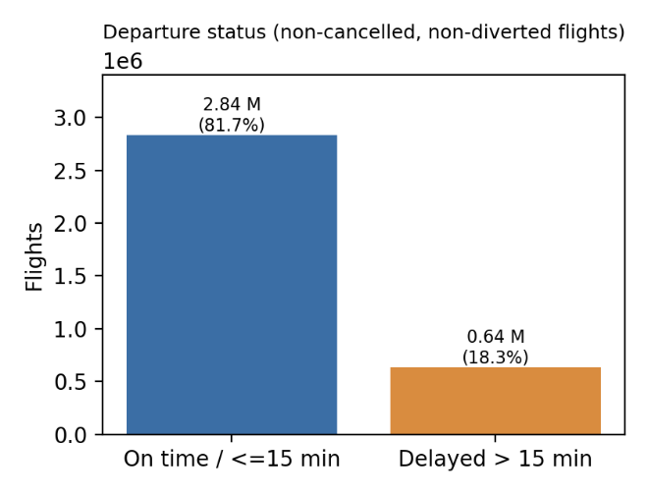
Fig. 1. Departure status of non-cancelled, non-diverted flights (15-minute rule).
Figure 2 shows the number of flights delayed by more than 15 minutes for the twelve airlines with the most delayed departures. Absolute counts are dominated by the airlines with the largest operations and mainly reflect operating volume, not relative punctuality.

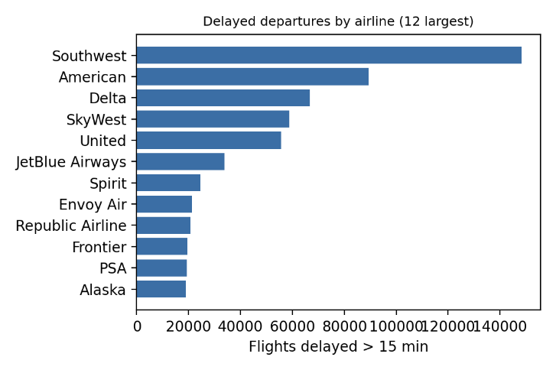
Fig. 2. Delayed departures (>15 min) by airline.
Among the 533,863 delayed flights for which the DOT reports delay causes, the dominant cause (largest cause minutes) was late arrival of the aircraft in 36.5% of the flights, the carrier in 33.7%, the national air system in 25.7%, weather in 3.8% and security in 0.3% (Figure 3). Delay causes are reported only for flights with an arrival delay of at least 15 minutes and are post-event information; they are not used as model inputs.
The distribution shows that propagation of delays (late aircraft), carrier and national-air-system causes dominate, whereas weather-related and security-related causes are rare. This illustrates the class imbalance of the cause labels and why a delay propagation signal - such as the delays of earlier flights - is informative.

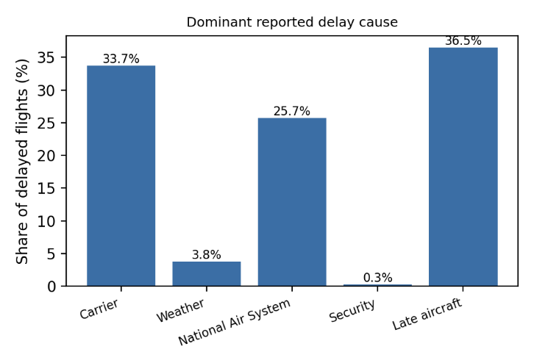
Fig. 3. Dominant reported delay cause.
The heatmap in Figure 4 shows the correlations between the minutes attributed to the five delay causes among delayed flights.
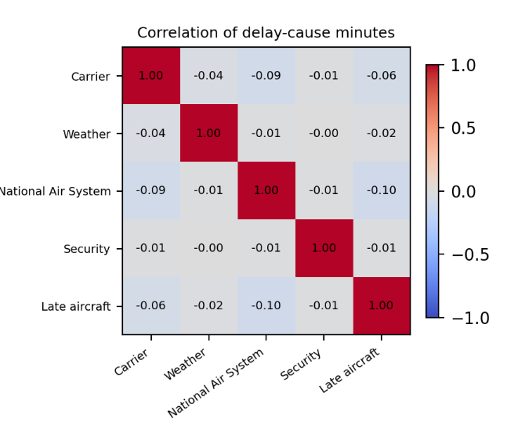
Fig. 4. Correlation of the minutes attributed to the five delay causes.
  - Meteorological Data Integration and Processing Process

Weather is one of the main external factors that affect the timely execution of flights (Schultz, Reitmann & Alam, 2021). Flight data and Meteostat observations were combined as follows.
Stage 1 - airport coordinates and stations: the coordinates of each origin and destination airport were taken from the open airportsdata package (IATA codes). Point-based interpolation in the Meteostat library failed for many airports, so station observations were used directly: the nearest weather stations within 50 km of the airport were selected, the nearest station with sufficient data served as the primary source, and its missing days were filled from the next-nearest stations (at most three stations). Two of 382 origin airports could not be matched (no coordinates or no station data).
Stage 2 - daily observations from 31 December 2018 to 31 January 2024 were retrieved with Meteostat's Daily class. Seven variables are used:
• tmin: daily minimum temperature (°C)
• tmax: daily maximum temperature (°C)
• prcp: total precipitation (mm)
• snow: snow depth (mm)
• tavg: daily mean temperature (°C)
• wspd: average wind speed (km/h)
• pres: average sea-level pressure (hPa)

Stage 3 - look-ahead control: a flight on day D receives the observation of day D-1, because the same-day daily aggregate (for example the maximum temperature or the total precipitation) is only known after the day has ended and would leak future information into predictions for morning flights. The merge is a many-to-one join on (airport, date) and does not change the number of flights. Coverage of the D-1 values is 99.7% for temperature and wind speed, 99.1% for pressure, 90.5% for precipitation and 66.6% for snow (missing snow values mostly mean that no snow was reported).
Missing weather values are left missing for the tree-based models (native handling). Because only daily and previous-day values are used, the weather information is coarse: it cannot represent the conditions at the hour of departure, and the models should be read as risk indicators based on recent observations, not as weather-forecast-driven predictions.

  - Data Preprocessing

The success of machine learning models depends heavily on the data preprocessing phase (Dumitrascu & Aiordachioaie, 2022). In this study the preprocessing is designed mainly to avoid information leakage from the evaluation period and to keep the natural class distribution; it is described in the following stages.
Stage 1 - harmonisation and de-duplication: Zelaya and Singh records were mapped to a common schema (carrier, DOT identifier, flight number, origin and destination airport, scheduled times, distance, cancellation flag and code, diversion flag, departure delay). Duplicates were checked on flight date, DOT identifier, flight number, origin, destination and scheduled departure time. Cancelled flights are excluded from the delay task, diverted flights are excluded from the delay task, and the cancellation-cause task uses cancelled flights with the DOT codes A (carrier), B (weather) and C (national air system). Code D (security) was excluded because it is almost entirely a COVID-year artefact (38% of training-period cancellations but only 6 and 27 cases in the validation and test periods); a class N ('other'), which can be created by filling missing codes, is not a DOT code and is not used.
Stage 2 - features available before departure: variables that are only known after the event (actual departure and arrival times, taxi, wheels, elapsed and air times, delay causes) are excluded, as are the flight number and the calendar year. Calendar and schedule: month and day of year (sine/cosine), day of week, days to and since the nearest U.S. federal holiday, scheduled departure and arrival minute, distance, and the log of the number of training-period flights on the route. Categorical: airline, origin and destination airport (native categorical handling; categories unseen in the training period are treated as missing). Weather: the seven D-1 variables at the origin and, for temperature, precipitation, snow and wind, at the destination. History (Mode A and B): cancellation rate, share of departures delayed by more than 15 minutes and mean departure delay (clipped to -30..180 minutes) of the previous day (D-1) and of the seven previous days, nation-wide, per origin airport and per airline; the two rates are shrunk towards training-period priors with 30 pseudo-flights. Same-day state (Mode B only): the same three statistics for the flights of the same day whose events had occurred at least three hours before the scheduled departure, plus the share of flights scheduled by then that had not yet departed. The complete feature set is listed in Table 5; the three tasks use identical inputs (44 in Mode A and 56 in Mode B).
Table 5
Input features of the models (l = NAT nation-wide, ORG origin airport or AIR airline; w = D1 previous day or D7 seven previous days). The cancellation, cancellation-cause and delay models use identical inputs: 44 in Mode A (41 numeric, 3 categorical) and 56 in Mode B (53 numeric, 3 categorical). Same-day statistics are shrunk towards training-period priors in the same way as the history rates. Not used: the flight number, the calendar year and all variables known only after departure (Table 4).
Group | Feature(s) | Description | Mode
Calendar | MONTH_SIN, MONTH_COS | Month of the flight date, sin/cos(2π·month/12) | A, B
 | DOY_SIN, DOY_COS | Day of the year, sin/cos(2π·day/366) | A, B
 | DAY_OF_WEEK | Day of the week (0 = Monday) | A, B
 | DAYS_TO_HOLIDAY, DAYS_SINCE_HOLIDAY | Days to the next and since the previous U.S. federal holiday (capped at 14) | A, B
Schedule | CRS_DEP_MIN, CRS_ARR_MIN | Scheduled departure and arrival time (local time, minutes after midnight) | A, B
 | DISTANCE | Route distance (miles) | A, B
 | ROUTE_COUNT_LOG_TRAIN | log(1 + number of training-period flights on the origin-destination route) | A, B
Categorical | AIRLINE_CODE, ORIGIN, DEST | Reporting airline, origin and destination airport (native categorical; categories not seen in training are treated as missing) | A, B
Weather, origin (D-1) | D1_tmin, D1_tmax, D1_tavg, D1_prcp, D1_snow, D1_wspd, D1_pres | Minimum, maximum and mean temperature (°C), precipitation (mm), snow depth (mm), mean wind speed (km/h) and sea-level pressure (hPa) observed at the origin airport on the previous day | A, B
Weather, destination (D-1) | DEST_D1_tmin, DEST_D1_tmax, DEST_D1_prcp, DEST_D1_snow, DEST_D1_wspd | The same observations at the destination airport (without mean temperature and pressure) | A, B
History (D-1, D-7) | H_l_w_CANCEL | Share of cancelled flights; shrunk towards the training prior (30 pseudo-flights) | A, B
 | H_l_w_DELAY15 | Share of operated flights that departed more than 15 min late; shrunk as above | A, B
 | H_l_w_MEANDELAY | Mean departure delay of operated flights (clipped to -30..180 min) | A, B
Same day (T-3 h) | L_l_CANCEL | Share of the flights scheduled before the cut-off (scheduled departure minus 3 h) that were cancelled | B
 | L_l_DELAY15 | Share of the flights departed by the cut-off with a delay of more than 15 min | B
 | L_l_MEANDELAY | Mean departure delay (clipped) of the flights departed by the cut-off | B
 | L_l_BACKLOG | Share of the non-cancelled flights scheduled by the cut-off that had not yet departed | B

Stage 3 - chronological split: training 2019-01 to 2022-06, validation 2022-07 to 2022-12, test 2023-01 to 2023-08 and 2024-01 (Table 3). All learned quantities (category lists, route counts, prior rates, models) are fitted on the training period only; hyper-parameters and decision thresholds are chosen on the validation period; the test period is used once at the end.

Missing values: tree-based XGBoost models handle missing values natively, so no imputation was applied to them. For the comparison models (logistic regression, decision tree, random forest, histogram gradient boosting) numeric missing values were replaced by training-period medians. Meteostat variables with more than 50% missing values (wind direction, gust, sunshine duration) were not used.
Outliers: no flights were removed. Extreme departure delays (up to 2,690 minutes) are clipped to the range -30..180 minutes only inside the aggregated history features, and are kept unclipped in the target classes.
Leakage control: two automated tests protect the history and same-day features. In the first, the labels and delays of one calendar day are altered; the features of that day must remain unchanged while the features of the next day must change. In the second, every event after the cut-off time and the flight itself are altered for 300 target flights; the same-day features must remain unchanged. Both tests are part of the code base. The prior rates used for shrinkage are fixed from the training period.
Scaling and encoding: tree-based models do not require standardisation. For the comparison models, logistic regression used standardised numeric features and one-hot encoded airline codes (origin and destination were not included), while the tree-based comparison models used integer category codes.
Class imbalance: cancellations are rare (2-3% of flights). The final XGBoost models use no resampling. We compared no balancing, class weighting (scale_pos_weight) and SMOTE-NC applied to the training period only (Section 4.4.4). Resampling is applied to the training part only and never before the chronological split, because applying SMOTE to the whole data set or before time-series cross-validation lets synthetic samples leak across folds; SMOTE-NC is used instead of SMOTE because the inputs include categorical variables.
Targets: cancellation is a binary target over all flights. The cancellation cause is a three-class target (A carrier, B weather, C national air system) over cancelled flights. The delay target has four classes over non-cancelled, non-diverted flights, defined from the departure delay in minutes:
Delay classes (departure delay in minutes):
• Class 0: On time or early (≤ 0 minutes)
• Class 1: Slight delay (1-15 minutes)
• Class 2: Medium delay (16-30 minutes)
• Class 3: Serious delay (>30 minutes)
The class distributions of the three targets in the training, validation and test periods are given in Table 6. The delay-class shares change over time (class '<=0 min' falls from 68% in training to 60% in the test period), a distribution shift that affects all delay results.
Table 6
Targets and class distributions in the training, validation and test periods (number of flights and share).
Task | Class | Training | Validation | Test
Cancellation | Not cancelled | 2,123,139 (97.1%) | 342,046 (97.8%) | 1,016,027 (97.1%)
Cancellation | Cancelled | 63,786 (2.9%) | 7,545 (2.2%) | 29,882 (2.9%)
Cause | A carrier | 14,214 (36.1%) | 3,050 (40.5%) | 10,061 (33.7%)
Cause | B weather | 20,566 (52.2%) | 3,820 (50.7%) | 17,961 (60.2%)
Cause | C national air system | 4,622 (11.7%) | 669 (8.9%) | 1,833 (6.1%)
Delay | 0: <=0 min | 1,445,242 (68.2%) | 209,448 (61.4%) | 607,707 (60.0%)
Delay | 1: 1-15 | 331,100 (15.6%) | 63,004 (18.5%) | 180,379 (17.8%)
Delay | 2: 16-30 | 120,174 (5.7%) | 24,577 (7.2%) | 74,115 (7.3%)
Delay | 3: >30 | 221,656 (10.5%) | 44,189 (13.0%) | 150,928 (14.9%)
Feature contributions were analysed with SHAP values computed with XGBoost's built-in TreeSHAP routine on a random sample of 30,000 test flights, and the multicollinearity of the final numeric feature set was assessed with variance inflation factors and correlation analysis (see Results). The whole process is shown in Figure 5.
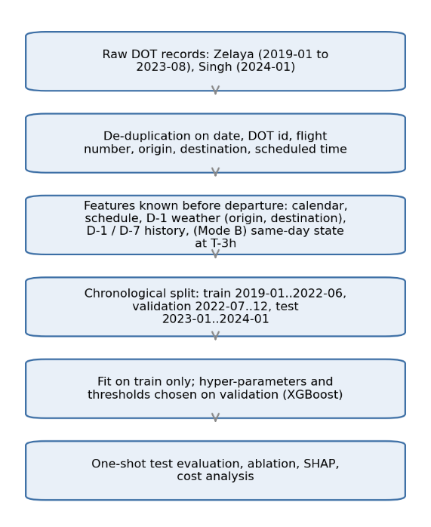
Fig. 5. Data processing and evaluation pipeline.
This protocol aims at honest estimates of future performance; it does not by itself guarantee high scores.
Implementation and reproducibility: the experiments were implemented in Python with XGBoost 3.4.1, scikit-learn, imbalanced-learn (SMOTE-NC), pandas, NumPy, statsmodels (variance inflation factors) and the Meteostat library. All random seeds are fixed: 42 for XGBoost and SMOTE-NC, 7 for the random hyper-parameter search, 0 for every random subsample (the 700,000-flight subsample of the delay search, the 1,000,000-flight subsample of the comparison models, the 30,000-flight SHAP sample and the 150,000-flight VIF sample) and 123 for the 100 bootstrap resamples. The scripts that produce all experimental results, tables and figures are referred to in the Data availability statement.

  - Supervised Learning Models

Machine learning is the general name for algorithms that enable computers to analyze data, discover possible patterns and make predictions using these patterns. These algorithms, which can provide information about the relative difficulty of learning in different environments, are divided into several categories (Ayodele, 2010). The two most common types of machine learning algorithms are supervised and unsupervised learning. Supervised learning algorithms create a function that transforms inputs into desired outputs. The main types of supervised learning include regression and classification. Unsupervised learning focuses on modeling a set of inputs without labeled examples.
In this study, a supervised learning approach is adopted and machine learning is used to predict flight cancelations and delays. Since the input data and the target outputs (e.g. delay class or cancellation status) are known, supervised learning algorithms are appropriate in this context. They are ideal tools for modeling complex relationships in airline operations and analyzing the impact of a large number of variables (Sternberg et al., 2017).
The Decision Tree algorithm solves classification and regression problems by partitioning the data hierarchically; each node tests one feature (Breiman, Friedman, Olshen & Stone, 1984). Trees are easy to interpret but unstable when used alone.
Logistic regression is a linear baseline that models the log-odds of each class. Histogram-based gradient boosting (scikit-learn; Pedregosa et al., 2011) is a fast boosting implementation inspired by LightGBM (Ke et al., 2017), which bins feature values into histograms to train quickly on large data sets.
Random Forest is an ensemble of decision trees trained on bootstrap samples with random feature selection (Breiman, 2001), which reduces overfitting relative to a single tree.
XGBoost is a regularised gradient-boosting algorithm that adds trees sequentially to correct the errors of the previous ones (Chen & Guestrin, 2016). It supports instance weights, native handling of missing values and categorical splits, and provides exact TreeSHAP contributions, which are useful for tabular problems with many interacting factors such as flight operations.
XGBoost was chosen as the main algorithm for the following practical reasons:
Imbalanced targets: cancellations are rare. XGBoost allows instance and class weights (scale_pos_weight) without generating synthetic records; whether weighting helps was tested rather than assumed (see the imbalance comparison in the Results section).
Scale and flexibility: it trains within minutes on 2.2 million training records, accepts missing values and high-cardinality categorical inputs such as airports, and exposes regularisation parameters that can be tuned systematically.
The choice is a pragmatic one. It is not claimed that XGBoost is superior in general; the comparison with four other algorithms is reported in the Results section, and, for cancellation and delay, the differences between the models turned out to be small compared with the effect of the information sources used.
Cancellation and cancellation-cause prediction are implemented as two separate models. The first model is a binary classifier over all flights (cancelled or not). The second is a three-class classifier (carrier, weather, national air system) that is applied only to flights that are cancelled. For both, categorical inputs (airline, origin, destination) are passed to XGBoost as native categorical features, and the hyper-parameters are tuned on the validation period.
The final models are trained on the natural class distribution. Resampling with SMOTE-NC and class weighting was only evaluated as a comparison; they are not part of the final models because SMOTE-NC reduced validation PR-AUC (see the imbalance comparison in the Results section).
Models are evaluated on the held-out test period with PR-AUC and ROC-AUC for the binary task, and with accuracy, macro-averaged F1, balanced accuracy, class-wise precision, recall and F1 and macro-averaged one-vs-rest ROC-AUC for the multi-class tasks. Confidence intervals are obtained by bootstrap resampling of the test flights (100 resamples). Overall accuracy is always reported next to the majority-class baseline.
Two separate models are used because the operational questions differ. Airlines and passengers first want to know whether a flight is likely to be cancelled; the cause is mostly relevant once a cancellation has occurred or is imminent (reporting and customer notification).
In addition, separate models allow the hyper-parameters, class weights and decision thresholds of each task to be tuned independently, and they keep the cause model free of the very different base rates of the binary task.
This two-stage structure was chosen for operational reasons; no experiment comparing it with a single joint model was run.
The global contributions of the inputs, measured by mean absolute SHAP values, are shown in Figures 6 to 8 for the cancellation, cancellation-cause and delay models (Mode B). A prediction function returns class probabilities for new flights, which is used by the prototype.
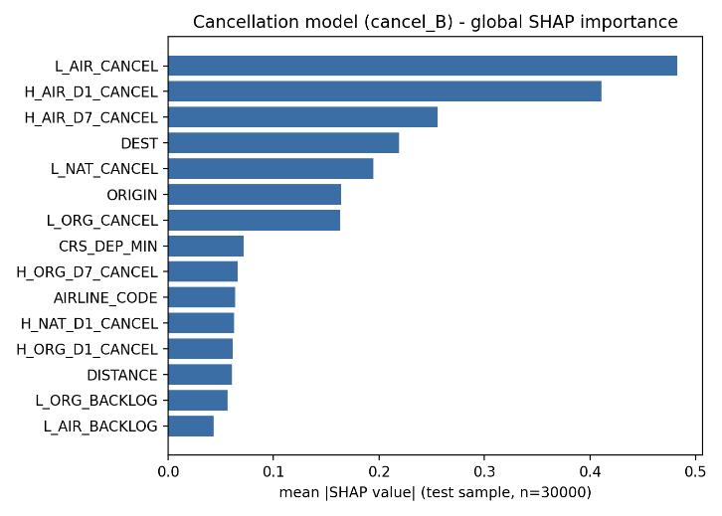
Fig. 6. Mean absolute SHAP values of the cancellation model (Mode B, test sample).
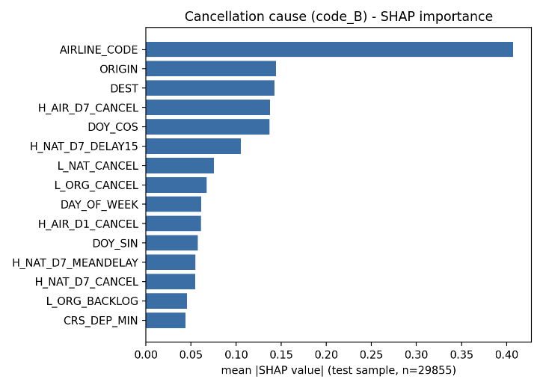
Fig. 7. Mean absolute SHAP values of the cancellation-cause model (Mode B, test sample).
The delay model is a four-class XGBoost classifier trained on non-cancelled, non-diverted flights with the minute-based classes defined above. Two variants are reported: an accuracy-oriented model without class weights, and a macro-F1-oriented model with balanced class weights.
The class weights increase the recall of the rare classes at the price of overall accuracy; which variant is preferable depends on whether the application values overall accuracy or the detection of rare long delays.
Hyper-parameters were tuned with a limited random search on the validation period (details in the Results section). Class probabilities are returned for all four delay classes.
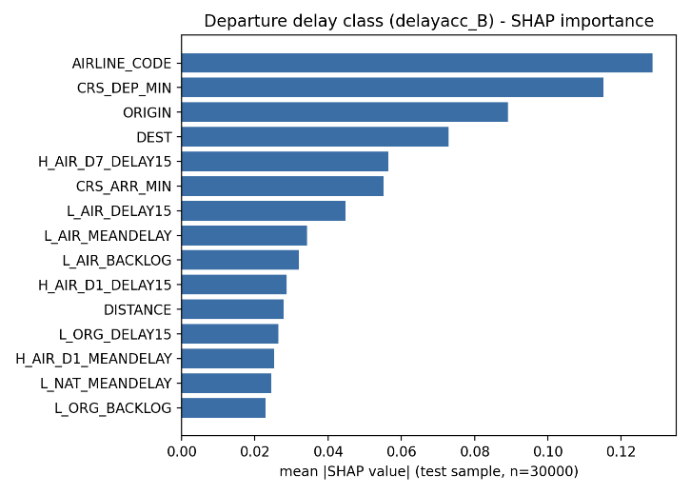
Fig. 8. Mean absolute SHAP values of the departure-delay model (Mode B, test sample).
The delay classes and their probabilities for a new flight are produced by the same feature pipeline as in training; the SHAP contributions of the delay model are shown in Figure 8.
SHAP contributions make the model's decisions more transparent, but they describe associations in the data and not causal effects.

  - Supervised Model Update and Maintenance Strategy

Given the dynamic nature of flight operations and meteorological patterns, a systematic update and maintenance strategy would be needed to preserve long-term performance (Gama, Žliobaitė, Bifet, Pechenizkiy & Bouchachia, 2014). Changes in airline procedures, airport infrastructure, air-traffic management and climate can cause discrepancies between training data and real-world conditions (Lu, Liu, Dong, Gu, Gama & Zhang, 2019). The strategy described below is a proposal; it has not been implemented or evaluated in this study.

    - Periodic Retraining Cycle

A three-month retraining cycle is proposed so that seasonal variation is observed and sufficient new data accumulate. Each quarter, the model would be retrained on the most recent 12 months of flight and weather data, with the last three months held out as a chronological test set. The strong month-to-month variation reported in the Results section shows that such monitoring would be necessary.

Results

This section reports the results on the held-out test period (January to August 2023 and January 2024), after all fitting, hyper-parameter selection and decision-threshold selection were completed on the training and validation periods. Two operating modes are reported: Mode A uses information up to the previous completed day (D-1) and is the only valid mode for tickets booked in advance; Mode B additionally uses the operational state of the same day observed three hours before departure and needs a live data feed. Because cancellations are rare, PR-AUC (whose no-skill value equals the prevalence; Saito & Rehmsmeier, 2015), ROC-AUC, class-wise precision and recall and macro-averaged scores are reported in addition to accuracy, and accuracy is always compared with the majority-class baseline. Values in brackets are 95% bootstrap confidence intervals over the test flights; they quantify test-sampling uncertainty only.

  - Flight Cancellation Forecasting Model Results

Flight cancellation is a rare event (prevalence 2.86% in the test period). The binary XGBoost model reached a test PR-AUC of 0.119 (0.116-0.122) and a ROC-AUC of 0.800 in Mode A, and 0.196 (0.191-0.200) and 0.857 in Mode B, i.e. 4.2 and 6.8 times the no-skill PR-AUC (Section 4.5.1).
With the decision threshold that maximises F1 on the validation period (0.149 in Mode A and 0.156 in Mode B), Mode B detects 36.8% of the cancelled flights at a precision of 20.9% (F1 0.266, macro-F1 0.618, balanced accuracy 0.664); Mode A detects 17.9% at a precision of 16.9% (F1 0.174, macro-F1 0.575). Most alarms are therefore false: roughly four of five flagged flights in Mode B are not cancelled. Table 7 lists the class-wise precision, recall and F1 of all three tasks in both modes.
The overall accuracy at these thresholds is 95.1% (Mode A) and 94.2% (Mode B), which is lower than the 97.1% obtained by predicting 'not cancelled' for every flight. Accuracy is therefore not a meaningful criterion for this task, and high accuracy values reported for rare-event targets should be read with caution.
The test period contains 1,045,909 flights, 29,882 of which were cancelled. In Mode B the confusion matrix at the validation threshold is TN 974,281, FP 41,746, FN 18,872, TP 11,010 (Figure 9). The ROC and precision-recall curves are shown in Figures 10 and 11.
Table 7
Class-wise test results of the XGBoost models in Mode A and Mode B (P = precision, R = recall; NAS = national air system). Cancellation: decision at the threshold that maximises F1 on the validation period; multi-class tasks: class with the highest predicted probability. Macro-averaged scores are unweighted means of these class-wise values.
Task | Class | n (test) | P (A) | R (A) | F1 (A) | P (B) | R (B) | F1 (B)
Cancellation | Not cancelled | 1,016,027 | 0.976 | 0.974 | 0.975 | 0.981 | 0.959 | 0.970
 | Cancelled | 29,882 | 0.169 | 0.179 | 0.174 | 0.209 | 0.368 | 0.266
Cause | A carrier | 10,061 | 0.589 | 0.841 | 0.693 | 0.632 | 0.850 | 0.725
 | B weather | 17,961 | 0.831 | 0.692 | 0.755 | 0.842 | 0.739 | 0.788
 | C NAS | 1,833 | 0.379 | 0.114 | 0.175 | 0.408 | 0.128 | 0.194
Delay, unweighted | <=0 min | 607,707 | 0.632 | 0.960 | 0.762 | 0.647 | 0.952 | 0.770
 | 1-15 min | 180,379 | 0.343 | 0.071 | 0.118 | 0.349 | 0.067 | 0.113
 | 16-30 min | 74,115 | 0.176 | 0.000 | 0.000 | 0.139 | 0.000 | 0.000
 | >30 min | 150,928 | 0.374 | 0.131 | 0.194 | 0.439 | 0.243 | 0.313
Delay, class-weighted | <=0 min | 607,707 | 0.774 | 0.412 | 0.537 | 0.778 | 0.460 | 0.578
 | 1-15 min | 180,379 | 0.235 | 0.314 | 0.269 | 0.242 | 0.323 | 0.277
 | 16-30 min | 74,115 | 0.112 | 0.273 | 0.159 | 0.114 | 0.248 | 0.156
 | >30 min | 150,928 | 0.239 | 0.423 | 0.305 | 0.280 | 0.469 | 0.351

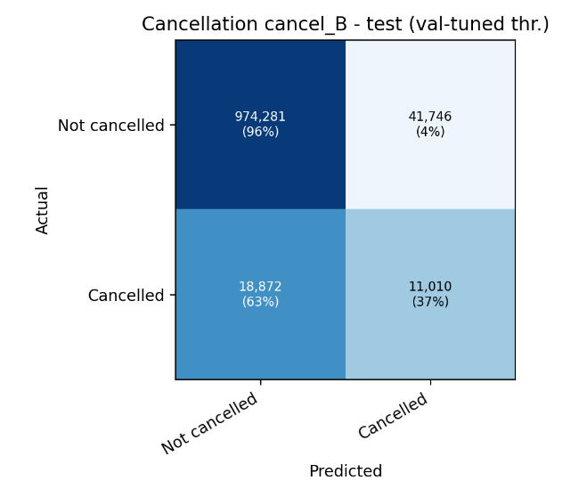
Fig. 9. Confusion matrix of the cancellation model (Mode B, validation-selected threshold, test period).
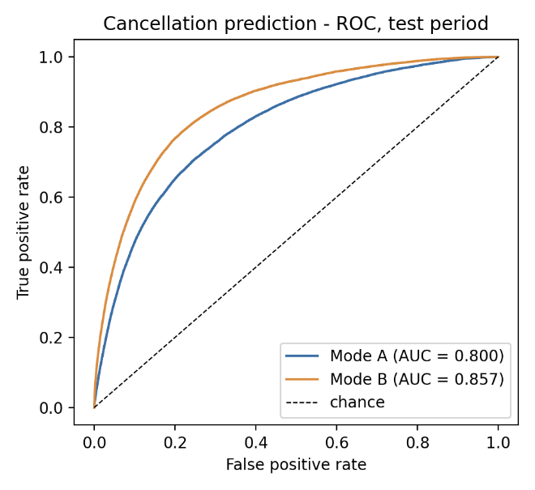
Fig. 10. ROC curves of the cancellation model (test period).
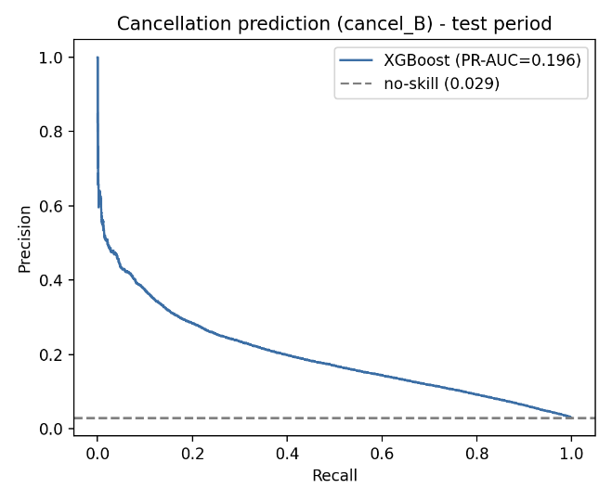
Fig. 11. Precision-recall curve of the cancellation model (Mode B, test period).

  - Cancellation Code Prediction Model Results

The cancellation-cause model assigns cancelled flights to the DOT classes carrier (A), weather (B) or national air system (C); the security class (D) and an 'other' class N were not used (see Data preprocessing). On the test period it reached an accuracy of 70.7% (70.1%-71.2%) in Mode A and 73.9% (73.4%-74.3%) in Mode B, compared with 60.2% for always predicting the most frequent class (weather). The macro-averaged F1 is 0.541 and 0.569, respectively (Section 4.5.1).

Class-wise (Mode B; Table 7), carrier-caused cancellations are recognised with precision 63.2%, recall 85.0% and F1 0.725, and weather-caused cancellations with precision 84.2%, recall 73.9% and F1 0.788. Mode A gives F1 0.693 and 0.755 for these two classes.
The national-air-system class (C) is rarely recognised: precision 40.8%, recall 12.8% and F1 0.194 in Mode B (Mode A: recall 11.4%). This class is rare (6.1% of test cancellations, 11.7% of training cancellations) and its causes (air-traffic management measures) are hard to infer from schedule, history and daily weather.
The accuracy gain over the majority baseline is 10.5 percentage points in Mode A and 13.7 points in Mode B. The distribution of causes changes over time (the share of weather-caused cancellations is 52.2% in the training period and 60.2% in the test period, that of carrier-caused cancellations 36.1% and 33.7%), which limits the transferability of the cause model.

  - Flight Delay Estimation Model Results

Departure-delay prediction is reported for four classes (<=0, 1-15, 16-30 and >30 minutes). The accuracy-oriented model without class weights reached an accuracy of 60.8% (60.7%-60.9%) in Mode A and 61.9% (61.8%-62.0%) in Mode B, whereas always predicting the most frequent class ('<=0 min') yields 60.0%; the macro-F1 is only 0.269 and 0.299 (Section 4.5.1). The four-class delay problem is thus only marginally predictable from information available before departure.
The confusion matrix of the unweighted Mode B model (Figure 12) shows that nearly all flights are assigned to the on-time class: the model mainly separates on-time flights from long delays, while the classes 1-15 and 16-30 minutes are almost never predicted.
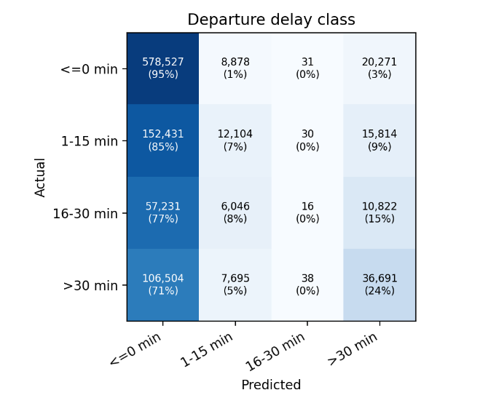
Fig. 12. Confusion matrix of the unweighted departure-delay model (Mode B, test period).
Class-wise (unweighted Mode B; Table 7), the class '<=0 min' has precision 64.7% and recall 95.2%, the class '1-15 min' precision 34.9% and recall 6.7%, the class '16-30 min' recall 0.0% and the class '>30 min' precision 43.9% and recall 24.3%.
With balanced class weights the recall of the delayed classes increases (macro-F1 0.318 in Mode A and 0.340 in Mode B; recall of the class '>30 min' 46.9% in Mode B) but the overall accuracy falls to 38.6% and 42.1%. The weighted variant is preferable if the detection of long delays is valued more than overall accuracy.
For the DOT definition of a delayed flight (more than 15 minutes) the four class probabilities can be collapsed to a binary score; its ROC-AUC is 0.693 (Mode A) and 0.721 (Mode B) and its PR-AUC 0.386 and 0.446 (prevalence 0.222). The delay results should be seen in the light of a distribution shift: the share of delayed flights rises from 32% in the training period to 40% in the test period. The one-vs-rest ROC curves of the unweighted Mode B model (Figure 13) give AUC values from 0.64 (1-15 min) to 0.72 (>30 min); the two extreme classes are separated best.
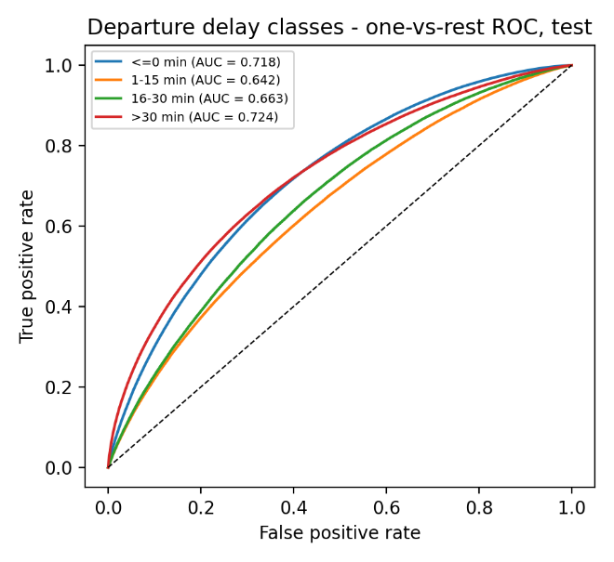
Fig. 13. One-vs-rest ROC curves of the departure-delay model (Mode B, test period).

  - Model Optimization and Evaluation Techniques

Hyper-parameters, decision thresholds and the class-weighting scheme were selected on the validation period only; the test period was not used for any selection. The procedures are described in the following subsections.

    - Temporal Stability of the Results

Instead of a random K-fold split, the models are assessed with a single strictly chronological train/validation/test split and by examining performance month by month in the test period (Cerqueira, Torgo & Mozetič, 2020). Random K-fold validation ignores the time-series character of flight data and can produce optimistic estimates.
Cancellation performance varies strongly between months (Table 8, Figure 14): the monthly PR-AUC ranges from 0.013 to 0.220 in Mode A and from 0.026 to 0.275 in Mode B, and the monthly ROC-AUC from 0.62 to 0.83 (Mode A) and 0.70 to 0.87 (Mode B). Cancellations are concentrated on a few disruption days: the 5% of days with the most cancellations account for 52% of all cancellations in the data (for example winter storms and the 2020 pandemic period); months with such events are predicted better, months with isolated cancellations (e.g. May 2023, prevalence 0.55%) hardly at all.
January 2024, a complete month of 582,425 flights, makes up 56% of the test flights, so the pooled test metrics are dominated by one winter month. The months of 2023 come from a 3-million-flight sample of the DOT records and are about ten times less dense. Pooled results should therefore be read together with the monthly values.
For the cause model the monthly accuracy ranges from 0.57 to 0.83, for the unweighted delay model from 0.57 to 0.66 (majority baseline per month 0.53-0.65); the delay model therefore beats the monthly majority baseline by at most a few percentage points in every month.
These month-to-month differences reflect changes in the class distribution, weather regimes and operations. The absolute numbers should be expected to differ for other periods, other airports and other years.
Table 8
Monthly test performance of the cancellation model (Mode A / Mode B).
Month | Flights | Cancel. rate | PR-AUC A | PR-AUC B | ROC-AUC A | ROC-AUC B
2023-01 | 55,321 | 1.98% | 0.074 | 0.147 | 0.747 | 0.826
2023-02 | 51,026 | 1.92% | 0.220 | 0.275 | 0.810 | 0.874
2023-03 | 59,009 | 1.29% | 0.024 | 0.081 | 0.620 | 0.740
2023-04 | 57,289 | 1.79% | 0.059 | 0.118 | 0.719 | 0.762
2023-05 | 59,447 | 0.55% | 0.013 | 0.026 | 0.624 | 0.702
2023-06 | 58,668 | 2.07% | 0.170 | 0.216 | 0.831 | 0.847
2023-07 | 61,270 | 2.44% | 0.077 | 0.191 | 0.766 | 0.803
2023-08 | 61,454 | 1.48% | 0.034 | 0.095 | 0.660 | 0.764
2024-01 | 582,425 | 3.79% | 0.128 | 0.211 | 0.797 | 0.858
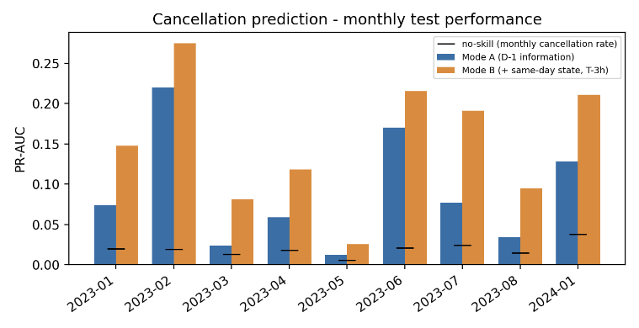
Fig. 14. Monthly test PR-AUC of the cancellation model (Modes A and B).

    - Validation and Test Performance

Because the models are tuned on the validation period, a large drop on the test period would indicate overfitting to the validation data or a distribution shift. Cancellation PR-AUC falls from 0.228 (validation) to 0.119 (test) in Mode A and from 0.295 to 0.196 in Mode B. The accuracy of the cause model changes from 68.7% to 70.7% (Mode A) and from 69.4% to 73.9% (Mode B); the accuracy of the unweighted delay model from 62.9% to 60.8% and from 63.4% to 61.9%.
The cancellation result is the clearest case of degradation. Since the test period differs from the validation period in its composition (Table 8), the decline cannot be attributed to a single cause; it is consistent with the high month-to-month variation and with a limited number of disruption events in each period.

    - Hyper-parameter Optimization

Hyper-parameters were optimised by random search (Bergstra & Bengio, 2012) on the validation period. The search space was: learning rate 0.03-0.15 (log-uniform), maximum depth 4-10, minimum child weight 1-60 (log-uniform), row subsample 0.6-1.0, column subsample 0.5-1.0, L2 regularisation lambda 0.5-20 (log-uniform), L1 regularisation alpha in {0, 0.1, 0.5, 1, 3}, gamma in {0, 0.5, 1, 3} and the class-weight scheme (cancellation: scale_pos_weight in {1, sqrt(n_neg/n_pos), n_neg/n_pos}; multi-class tasks: none, square-root or balanced weights). Twelve configurations were evaluated for the cancellation model, twenty for the cause model and eight for the delay models (on a random subsample of 700,000 training flights; the final delay models were refitted on all training flights). The objective was the validation PR-AUC for the cancellation model, the macro-F1 for the cause model and the class-weighted delay model, and the accuracy for the unweighted delay model. The number of trees was set by early stopping on the validation period (at most 800 trees). The test period was not touched.
The regularisation parameters (gamma, minimum child weight, lambda, alpha, maximum depth and the subsampling rates) are part of this search and were not adjusted manually. The selected values are listed in Table 9. Across the twelve cancellation configurations the validation PR-AUC ranged from 0.254 to 0.299 (Mode B), and across the twenty cause configurations the validation macro-F1 from 0.568 to 0.645, so the results are moderately sensitive to the hyper-parameters. The search was deliberately limited, used a single random seed and no nested validation. The selected configuration was then refitted on all training flights with its hyper-parameters stored to four decimal places and with an early-stopping patience of 50 instead of 40 rounds; therefore the validation PR-AUC of the final Mode B cancellation model (0.295, Section 4.4.2) differs slightly from that of the best search run (0.299), and its number of trees from 310 to 237. All reported results refer to the refitted final models.
Table 9
Selected XGBoost hyper-parameters (Mode B models).
Model | lr | depth | min child w. | subsample | colsample | lambda | alpha | gamma | weights | trees
Cancellation | 0.041 | 4 | 2 | 0.80 | 0.69 | 2.91 | 0.5 | 0.5 | none | 237
Cause | 0.082 | 5 | 6 | 0.89 | 0.92 | 0.93 | 3 | 1 | none | 115
Delay (unweighted) | 0.053 | 5 | 30 | 0.91 | 0.66 | 4.13 | 3 | 3 | none | 797
Delay (weighted) | 0.082 | 7 | 2 | 0.76 | 0.83 | 2.53 | 0.1 | 0 | balanced | 799

    - Imbalance Handling and Rare-Class Predictions

Three ways of handling the rarity of cancellations were compared on the validation period with a basic feature set (calendar, schedule, previous-day weather at the origin and the training-period cancellation rate of the airline; Table 10): no balancing, class weighting, and SMOTE-NC (Chawla et al., 2002) applied to the training period only, with airline, origin and destination as categorical features. With weather, the validation PR-AUC was 0.058 without balancing, 0.064 with class weighting and 0.046 with SMOTE-NC; without weather the corresponding values were 0.050, 0.058 and 0.052. SMOTE-NC therefore did not improve the ranking quality, and the final models use no resampling. Precision, recall and F1 in the table refer to the validation threshold that maximises F1. The values in Table 10 come from a separate experiment and are not directly comparable with the ablation in Table 11 (for example 0.058 here against 0.069 for feature set A): to allow SMOTE-NC, missing numeric values are imputed with training-period medians, the training-period cancellation rate of the airline is an additional input, and the learning rate is 0.05 with at most 600 trees, whereas the ablation keeps missing values for native handling and uses a learning rate of 0.08, at most 800 trees and a square-root class weight (scale_pos_weight = sqrt(n_neg/n_pos)). Comparisons are therefore made within each table.
The rare classes remain difficult in the final models: the recall of the national-air-system cancellations is 13% (Mode B) and the class of delays of 16-30 minutes is not predicted by the unweighted delay model. Cost-sensitive learning (Elkan, 2001) and class weighting trade overall accuracy for rare-class recall; the choice depends on the application and is not made here.
Table 10
Imbalance handling for cancellation prediction (validation period, basic feature set).
Weather | Method | PR-AUC | ROC-AUC | Precision | Recall | F1
with D-1 weather | no balancing | 0.058 | 0.719 | 0.074 | 0.232 | 0.113
with D-1 weather | class weights | 0.064 | 0.704 | 0.094 | 0.160 | 0.119
with D-1 weather | SMOTE-NC (train only) | 0.046 | 0.679 | 0.111 | 0.118 | 0.114
without weather | no balancing | 0.050 | 0.704 | 0.064 | 0.412 | 0.110
without weather | class weights | 0.058 | 0.698 | 0.087 | 0.341 | 0.138
without weather | SMOTE-NC (train only) | 0.052 | 0.634 | 0.126 | 0.261 | 0.170

    - Model Performance and Explainability

This subsection analyses which inputs matter (ablation and SHAP), how correlated the inputs are, and what the predictions would mean in cost terms.
Ablation (Table 11, validation period): starting from calendar, schedule and previous-day weather (set A), adding the history features raises the cancellation PR-AUC from 0.069 to 0.212. Adding holidays and destination weather (set C: 0.207) does not help further, and removing the weather variables altogether does not hurt (set D: 0.220); removing the history features instead drops the PR-AUC to 0.067. The same-day state of Mode B raises it to 0.283 (set G). For the cause model, the accuracy rises from 54.8% (set A) to 61.7% (set C) and 64.5% with the same-day state, and weather variables contribute a few points there (set C vs D: 61.7% vs 59.1%). For the unweighted delay model the accuracy is nearly unchanged across all feature sets (61.5%-63.2%). Weather observed on the previous day therefore adds little to the prediction of cancellations once recent operational history is known, presumably because the history already reflects the weather regime.
Table 11
Feature ablation on the validation period (default hyper-parameters: learning rate 0.08, maximum depth 6, at most 800 trees; cancellation with scale_pos_weight = sqrt(n_neg/n_pos), cause with balanced class weights, delay without class weights on a 700,000-flight training subsample).
Feature set | Cancel PR-AUC | Cause acc. | Delay acc.
A: calendar + schedule + D-1 origin weather | 0.069 | 54.8% | 61.6%
B: A + history | 0.212 | 59.3% | 62.7%
C: B + holiday + destination weather | 0.207 | 61.7% | 62.7%
D: C without weather | 0.220 | 59.1% | 62.7%
E: C without history | 0.067 | 55.4% | 61.6%
F: calendar + schedule only | 0.045 | 52.8% | 61.5%
G: C + same-day state (Mode B) | 0.283 | 64.5% | 63.2%
H: G without weather | 0.282 | 62.7% | 63.1%
I: calendar + schedule + same-day state | 0.238 | 57.4% | 63.0%
Explainability: SHAP contributions (Lundberg & Lee, 2017) were computed for 30,000 random test flights. In the Mode B cancellation model the most important inputs are the same-day cancellation rate of the airline (L_AIR_CANCEL), the previous-day and previous-week airline cancellation rates (H_AIR_D1_CANCEL, H_AIR_D7_CANCEL), the destination airport and the nation-wide same-day cancellation rate (Figure 6). The cause model relies mainly on the airline (AIRLINE_CODE), the airports and the seasonal position of the date (Figure 7), and the delay model on the airline, the scheduled departure minute and the airports (Figure 8). Meteorological inputs do not appear among the most important features of the cancellation model.
SHAP values describe how the fitted model uses its inputs; they do not establish causal effects, and because many inputs are strongly correlated (see below) importance is shared between them. The calendar year and ad-hoc composite weather scores are deliberately not used as inputs: the year can act as a proxy of the label, and a composite score without a validated formula cannot be justified.
Cost-sensitive alerting: the costs of a false alarm and of a missed cancellation are unknown and depend on the user (passenger, airline), so we analyse relative costs: a false alarm costs one unit and a missed cancellation costs r units. For each r the decision threshold that minimises the total cost on the validation period is applied to the test period (Table 12, Figure 15). In Mode B alerts do not pay off at r = 2 (-2.9% relative to issuing no alerts), and save 7.9%, 25.0%, 43.8% and 64.9% at r = 5, 10, 20 and 50; at r = 10 the alert rate is 10.5%, recall 56.2% and precision 15.3%. These figures depend entirely on the assumed cost ratio and on the prevalence of the test period; they are not monetary estimates. No threshold or annual monetary benefit derived from assumed unit costs is reported, because the unit costs are not known and an extrapolation to a year would not be justified. Confusion matrices are given in Figure 9.
Table 12
Cost-sensitive alerting for cancellations, Mode B, test period (thresholds chosen on the validation period).
Cost ratio FN:FP | Threshold | Alert rate | Recall | Precision | Saving vs. no alert
2:1 | 0.298 | 1.6% | 17.2% | 30.0% | -2.9%
5:1 | 0.143 | 5.7% | 39.6% | 20.0% | +7.9%
10:1 | 0.084 | 10.5% | 56.2% | 15.3% | +25.0%
20:1 | 0.043 | 18.4% | 72.3% | 11.3% | +43.8%
50:1 | 0.018 | 32.4% | 85.9% | 7.6% | +64.9%
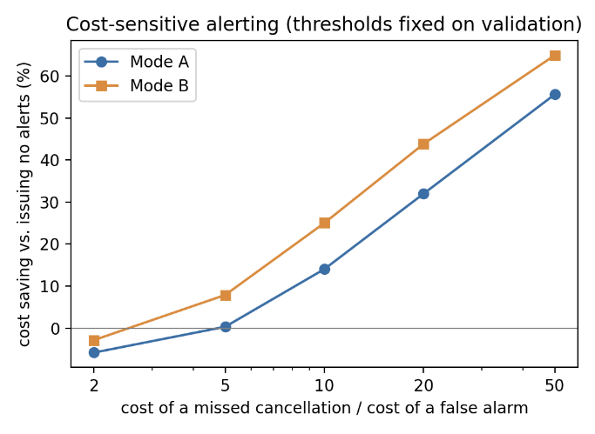
Fig. 15. Relative cost saving of alerting as a function of the cost ratio (thresholds from validation).
Multicollinearity: variance inflation factors were computed for the 53 numeric features of the final feature set on a 150,000-flight training sample (Table 13, Figure 16). 20 features have VIF above 10 and 27 feature pairs have an absolute correlation of at least 0.8 (O'Brien, 2007). The highest values belong to the nested history aggregates (7-day versus previous-day, nation-wide versus airport-level) and to the sine/cosine calendar encodings. Gradient-boosted trees are robust to collinearity as far as prediction is concerned, but SHAP importance is split between correlated features.
Table 13
Ten largest variance inflation factors of the numeric features (training sample).
Feature | VIF
H_NAT_D7_DELAY15 | 152.9
H_NAT_D7_MEANDELAY | 151.4
D1_tavg | 73.6
H_NAT_D1_DELAY15 | 65.3
H_NAT_D1_MEANDELAY | 60.5
DOY_COS | 48.0
MONTH_COS | 47.3
MONTH_SIN | 46.4
DOY_SIN | 45.7
L_NAT_MEANDELAY | 27.8
The delay model faces a harder problem: its four classes overlap strongly, the signal available before departure is weak, and the class shares shift between the periods. The model is informative for separating long delays (ROC-AUC above 0.69 for delays beyond 15 minutes) but not for the exact delay class.
In the delay model the most influential inputs are the airline, the scheduled departure minute, the airports and the recent airline-level delay rates (Figure 8).
The correlation structure of the features used in the models is shown in Figure 16.
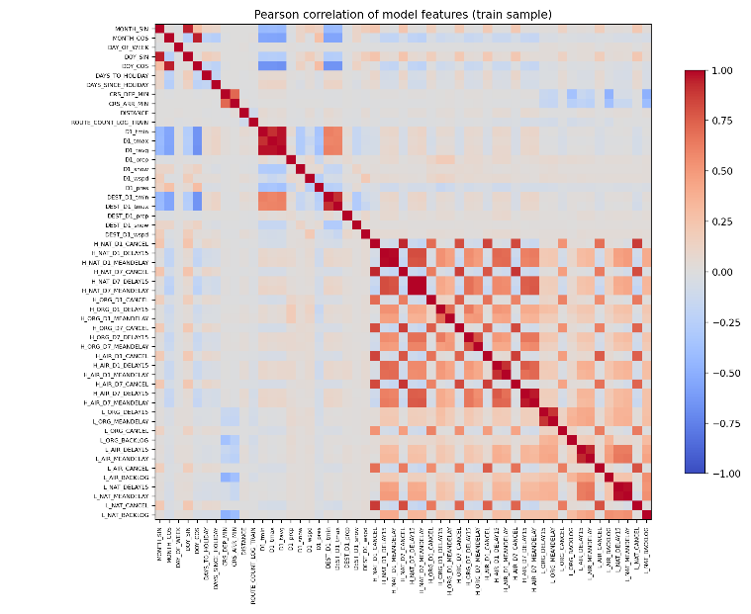
Fig. 16. Correlation matrix of the numeric model features (training sample).
Error analysis: in the unweighted Mode B delay model, 177,476 flights that departed more than 15 minutes late were predicted as on time, while only 36,146 on-time flights were predicted as delayed. Misclassifications of this kind would result in missed warnings; the class-weighted model reverses this balance. No monetary impact is derived for the delay model.
In summary, both models are useful as risk indicators rather than as precise predictors: the cancellation model concentrates risk (about six to seven times the base rate in Mode B), the cause model clearly beats a majority baseline, and the delay model offers only modest information beyond the base rates.

  - Comparison with Other Algorithms and with the Literature

This section compares XGBoost with four other algorithms under the same protocol and then relates the work to the literature.

    - Comparison of Algorithms Under the Same Protocol

XGBoost was compared with logistic regression, a decision tree, a random forest and histogram-based gradient boosting. All models use the same features, the same chronological split and the same one-time test evaluation; the comparison models use fixed, untuned hyper-parameters and, for the cancellation and delay tasks, a random subsample of 1,000,000 training flights (XGBoost was tuned on the validation period and uses all training flights), so the comparison favours XGBoost to some extent. K-nearest neighbours was not evaluated because it is not tractable for 3.5 million records with categorical inputs. Tables 14, 15 and 16 report the results.
Table 14
Cancellation prediction: test results (precision, recall and F1 of the cancelled class at the validation-selected threshold).
Model (mode) | PR-AUC | ROC-AUC | Precision | Recall | F1
XGBoost (A) | 0.119 | 0.800 | 0.169 | 0.179 | 0.174
XGBoost (B) | 0.196 | 0.857 | 0.209 | 0.368 | 0.266
Logistic regression (A) | 0.101 | 0.761 | 0.158 | 0.151 | 0.155
Logistic regression (B) | 0.140 | 0.806 | 0.182 | 0.261 | 0.214
Decision tree (A) | 0.094 | 0.738 | 0.126 | 0.207 | 0.156
Decision tree (B) | 0.164 | 0.819 | 0.161 | 0.418 | 0.232
Random forest (A) | 0.113 | 0.785 | 0.182 | 0.114 | 0.140
Random forest (B) | 0.186 | 0.847 | 0.235 | 0.277 | 0.255
Hist. gradient boosting (A) | 0.102 | 0.776 | 0.149 | 0.126 | 0.137
Hist. gradient boosting (B) | 0.192 | 0.854 | 0.220 | 0.325 | 0.263

Test PR-AUC of the five algorithms, ranked: Mode A - XGBoost 0.119, Random forest 0.113, Hist. gradient boosting 0.102, Logistic regression 0.101, Decision tree 0.094; Mode B - XGBoost 0.196, Hist. gradient boosting 0.192, Random forest 0.186, Decision tree 0.164, Logistic regression 0.140 (no-skill 0.029). XGBoost has the highest or second-highest PR-AUC in both modes.
For every algorithm the same-day state improves the ranking quality (Mode A to Mode B), e.g. logistic regression 0.101 to 0.140 and XGBoost 0.119 to 0.196. The gain from the information source is larger than the differences between the algorithms.
Even without tuning, Hist. gradient boosting (0.192) and the random forest (0.186) come close to XGBoost (0.196) in Mode B, whereas logistic regression (0.140) and the decision tree (0.164) trail. The advantage of the tuned boosting model is therefore small, and part of it is due to tuning and to the use of all training flights.
Hence no claim of algorithmic superiority beyond a modest advantage is made; the choice of inputs matters more than the choice of algorithm.
Table 15
Cancellation-cause prediction: test results.
Model (mode) | Accuracy | Macro-F1 | Bal. acc. | Macro ROC-AUC
XGBoost (A) | 0.707 | 0.541 | 0.549 | 0.835
XGBoost (B) | 0.739 | 0.569 | 0.572 | 0.846
Logistic regression (A) | 0.760 | 0.572 | 0.559 | 0.845
Logistic regression (B) | 0.774 | 0.589 | 0.575 | 0.854
Decision tree (A) | 0.507 | 0.396 | 0.388 | 0.608
Decision tree (B) | 0.547 | 0.406 | 0.405 | 0.621
Random forest (A) | 0.637 | 0.444 | 0.450 | 0.729
Random forest (B) | 0.649 | 0.437 | 0.450 | 0.737
Hist. gradient boosting (A) | 0.647 | 0.494 | 0.511 | 0.778
Hist. gradient boosting (B) | 0.671 | 0.508 | 0.521 | 0.789

Test accuracy for the cancellation cause, ranked: Mode A - Logistic regression 76.0%, XGBoost 70.7%, Hist. gradient boosting 64.7%, Random forest 63.7%, Decision tree 50.7%; Mode B - Logistic regression 77.4%, XGBoost 73.9%, Hist. gradient boosting 67.1%, Random forest 64.9%, Decision tree 54.7%. The majority-class baseline is 60.2%.
The ranking of the algorithms differs between the periods. On the validation period XGBoost was best (accuracy 68.7% in Mode A, 69.4% in Mode B) ahead of logistic regression (65.3% and 67.0%), whereas on the test period logistic regression reached 76.0% and 77.4% against 70.7% and 73.9% for XGBoost. The distribution of the causes shifts between the periods (weather-caused share 52% in training, 60% in the test period), and the tuned boosted trees were less robust to this shift than a linear model.
XGBoost is reported as the primary model because model selection was fixed on the validation period and must not use the test period; the finding that a simple linear model generalised better to the test period is reported as a result, and it shows that no algorithm can be declared superior for the cause task.
Table 16
Departure-delay prediction (four classes): test results.
Model (mode) | Accuracy | Macro-F1 | Bal. acc. | Macro ROC-AUC | ROC-AUC >15 min
XGBoost (A) | 0.608 | 0.269 | 0.290 | 0.672 | 0.693
XGBoost, class-weighted (A) | 0.386 | 0.318 | 0.356 | 0.645 | 0.679
XGBoost (B) | 0.619 | 0.299 | 0.316 | 0.687 | 0.721
XGBoost, class-weighted (B) | 0.421 | 0.340 | 0.375 | 0.660 | 0.709
Logistic regression (A) | 0.598 | 0.260 | 0.284 | 0.653 | 0.674
Logistic regression (B) | 0.609 | 0.289 | 0.309 | 0.665 | 0.697
Decision tree (A) | 0.596 | 0.274 | 0.292 | 0.642 | 0.670
Decision tree (B) | 0.605 | 0.292 | 0.308 | 0.653 | 0.692
Random forest (A) | 0.603 | 0.235 | 0.273 | 0.658 | 0.686
Random forest (B) | 0.612 | 0.264 | 0.295 | 0.669 | 0.707
Hist. gradient boosting (A) | 0.605 | 0.270 | 0.291 | 0.665 | 0.688
Hist. gradient boosting (B) | 0.617 | 0.297 | 0.315 | 0.681 | 0.718

Test accuracy of the unweighted four-class delay models: XGBoost (A) 60.8%, Hist. gradient boosting (A) 60.5%, Random forest (A) 60.3%, Logistic regression (A) 59.8%, Decision tree (A) 59.6%, XGBoost (B) 61.9%, Hist. gradient boosting (B) 61.7%, Random forest (B) 61.2%, Logistic regression (B) 60.9%, Decision tree (B) 60.5%; the majority-class baseline is 60.0%.
All algorithms stay within a few percentage points of the majority baseline in accuracy; macro-F1 (0.26-0.30 for the unweighted models) and the macro ROC-AUC (0.63-0.69) show that the delay classes are only weakly separable. Only the class-weighted XGBoost models reach a macro-F1 above 0.31, at the price of an accuracy of about 39-42%.
In summary, no algorithm provides a clear gain over the majority baseline for the four-class delay target; the binary question of a delay beyond 15 minutes is answered with a ROC-AUC of 0.65-0.72 by all of them.

    - Relation to the Literature

For context, the methods, datasets, metrics and reported results of selected studies are summarised below. The values are quoted from the original publications. Datasets, targets, class definitions, validation protocols and metrics differ between the studies and from this work, and several of the studies are not peer-reviewed journal articles; no improvement over any of them is claimed.
Khaksar and Sheikholeslami used large-scale datasets of US and Iranian airline networks to predict flight delays (Khaksar & Sheikholeslami, 2019). As can be seen in Table 17, the performances of various machine learning algorithms are compared. In the study, algorithms such as J48 Decision Tree, K-Means Clustering, Bayes Classifier, Random Forest and Hybrid Method (Decision Tree + Clustering) were used and the highest accuracy was 71.39% with the hybrid method.
Table 17
Performance Results of Khaksar and Sheikholeslami Study.
Model | Accuracy (US) | Accuracy (Iran) | Min Recall  (%) | Max Recall (%) | Min Precision (%) |  | Max Precision (%)
J48 Decision Tree | 64.28 | 70.87 | 53.86 | 91.24 |  | 48.69 |  | 72.66
K-Means Clustering | 62.27 | 69.63 | 50.07 | 88.99 |  | 53.27 |  | 72.26
Bayes Classifier | 61.35 | 70.17 | 48.61 | 94.01 |  | 51.94 |  | 76.35
Random Forest | 67.43 | 72.11 | 52.34 | 83.78 |  | 51.37 |  | 75.15
Hybrid Method | 71.39 | 76.44 | 60.19 | 94.54 |  | 60.28 |  | 79.37

This value cannot be compared with the accuracy obtained in the present study: data, prediction target, class definition (binary or multi-class), validation protocol and class prevalence all differ, and accuracy on an imbalanced target depends strongly on the majority-class share. In this study the four-class delay accuracy is 60.8%-61.9% against a majority baseline of 60.0%.
The dataset used in Kurt's study is based on open-source data provided by the US Bureau of Transportation Statistics and the Federal Aviation Administration (FAA). The dataset contains information on US domestic commercial flights operated in August 2018. After cleaning, the dataset consists of 638,776 rows and 18 columns. In the dataset, 38.29% of the flights were found to be delayed (Kurt, 2019).
Supervised machine learning methods such as Decision Trees, Random Forest, Bagging Classifier, Extra Trees, Gradient Boosting and XGBoost Classifiers were used to predict flight delays. Metrics such as accuracy, recall and F1-Score were used for model performance evaluation. The success metrics obtained as a result of modeling with default parameters are shown in Table 18. The best results were obtained with Gradient Boosting and XGBoost models. In particular, the Gradient Boosting model was determined as the most successful method with 71.72% accuracy and 57.40% F1-Score.
Table 18
Performance Results of M.Kurt's Study.
Score Name | Model | Score
Accuracy  Scores | Decision Tree | 0.6777
Accuracy  Scores | Random Forest | 0.6808
Accuracy  Scores | Extra Trees | 0.6686
Accuracy  Scores | Bagging | 0.6867
Accuracy  Scores | Gradient Boosting | 0.7172
Accuracy  Scores | XGBoosting | 0.7165
Recall  Scores | Decision Tree | 0.3854
Recall  Scores | Random Forest | 0.3939
Recall  Scores | Extra Trees | 0.3099
Recall  Scores | Bagging | 0.4091
Recall  Scores | Gradient Boosting | 0.4971
Recall  Scores | XGBoosting | 0.4934
F1 Scores | Decision Tree | 0.4783
F1 Scores | Random Forest | 0.4862
F1 Scores | Extra Trees | 0.4176
F1 Scores | Bagging | 0.5002
F1 Scores | Gradient Boosting | 0.5740
F1 Scores | XGBoosting | 0.5716

The same reservation applies to these figures: Kurt's study uses a different period (August 2018), a binary delay label and a different validation protocol.
Yu Yanying et al. aimed to predict flight cancelations using 5 million flight data from 2016 in the USA (Yu, Mo & Li, 2019). The dataset contains 65 variables such as flight date, airline information, departure and arrival times, delay reasons (weather, security, airline-induced, etc.) and flight distance. After feature selection, 11 important variables were used in the model.
Logistic Regression, SVM (Support Vector Machines), Naive Bayes and Decision Tree were used as prediction models. Model performances were evaluated with metrics such as accuracy, PR (precision - recall), AUC (ROC Curve). SVM and Decision Tree showed the best performance with about 90% accuracy. Naive Bayes showed the lowest performance with 50.8% accuracy, while Logistic Regression reached 62.4% accuracy.
In particular, the Decision Tree model was found to be the most successful model for flight cancellation prediction with the highest AUC (0.558) and PR (0.439) values. The results show that the Decision Tree model is the most suitable method for flight cancellation prediction, while SVM provides an effective alternative with high accuracy. Figure 17 shows the performance results of this study.
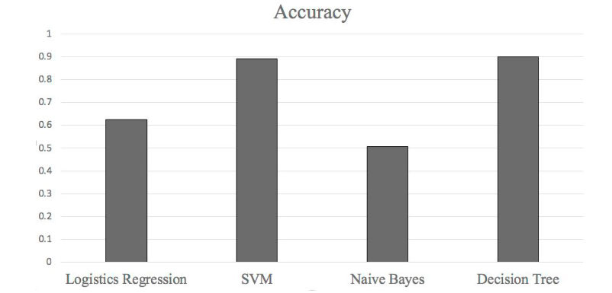
Fig. 17. Performance Results of Y.Yanying's Study.
These results cannot be compared with the metrics obtained here for cancellation prediction: the studies use different data sets and class prevalences, and the earlier-published accuracy of a rare-event classifier is not informative without class-sensitive metrics. The present study reports PR-AUC 0.119 (Mode A) and 0.196 (Mode B) against a no-skill value of 0.029.
In Giarmas' study, a dataset of 32,128,972 flights provided by the U.S. Department of Transportation on US domestic flights was used (Giarmas, 2025). The dataset covers flights between 2018 and 2022 and contains 121 different variables. Flight departure and arrival information, airline companies, time data and possible delay/interruption reasons are detailed. In particular, it was observed that ORD (Chicago O'Hare) airport has 1,499,216 flights and is among the most delayed airports.
In this study, various machine learning models were evaluated and their performances were compared in order to predict flight delays and cancelations. According to the findings, the Random Forest model was the most successful model in predicting flight delays with an accuracy of 77%. Alternatively, the XGBoost model gave satisfactory results with an accuracy of 73%, but did not perform as well as Random Forest in delay prediction. On the other hand, when the models for predicting flight cancelations were analyzed, it was determined that the Random Forest algorithm offered the highest performance with an accuracy rate of 83%. Table 19 and Table 20 show the performance results of this study.
Table 19
Flight Delay Model Performance Results of Giarmas' Study.
Model | Accuracy | Recall | Precision | F1 Score | AUC | RMSE | Execution Time
Decision Trees | 0.686545 | 0.666267 | 0.694655 | 0.680165 | 0.686555 | 0.559871 | 5.822055
Naive Bayes | 0.601815 | 0.556184 | 0.612306 | 0.582897 | 0.601837 | 0.631019 | 0.834699
Logistic Regression | 0.525055 | 0.517774 | 0.525677 | 0.521696 | 0.525059 | 0.689162 | 7.629777
XGBoost | 0.732887 | 0.689654 | 0.755148 | 0.720917 | 0.732908 | 0.516830 | 83.337318
SVM | 0.537776 | 0.521616 | 0.539294 | 0.530308 | 0.537784 | 0.679870 | 9.956836
Random Forest | 0.771258 | 0.722814 | 0.800560 | 0.759703 | 0.771282 | 0.478270 | 125.466779
KNN | 0.692317 | 0.616215 | 0.727104 | 0.667083 | 0.692354 | 0.554692 | 44.353603
Table 20
Flight Cancellation Model Performance Results of Giarmas' Study.
Model | Accuracy | Recall | Precision | F1 Score | AUC | RMSE | Execution Time
Decision Trees | 0.743762 | 0.739011 | 0.745426 | 0.742205 | 0.743754 | 0.506199 | 12.864707
Naive Bayes | 0.573631 | 0.434463 | 0.600788 | 0.504264 | 0.573388 | 0.652969 | 2.013837
Logistic Regression | 0.550082 | 0.526398 | 0.551661 | 0.538733 | 0.550041 | 0.670759 | 44.530750
XGBoost | 0.747930 | 0.757904 | 0.742439 | 0.750092 | 0.747947 | 0.502066 | 1381.146981
SVM | 0.797985 | 0.800399 | 0.795993 | 0.798190 | 0.797989 | 0.449461 | 326.619967
Random Forest | 0.556813 | 0.518243 | 0.560621 | 0.538599 | 0.556746 | 0.665723 | 421.932576
KNN | 0.745923 | 0.750650 | 0.742965 | 0.746788 | 0.745931 | 0.504061 | 113.055845

Again, the accuracies in Tables 19 and 20 (different data sets, targets and prevalences; the cancellation task there is a balanced task) are not comparable with the results reported here.
Ahlam Ansari et al. aimed to predict ticket cancellations using an airline dataset of Indian domestic flights (Ansari et al., 2019). The dataset contains various reservation-based features such as ticket price, booking date, number of passengers, and nationality of the passenger. In the feature engineering process, redundant components of the data were removed and only data pertaining to ticket bookings (AIR entries) were selected and analyzed.
Four different machine learning classification algorithms, namely Logistic Regression, Decision Trees, Random Forest and Gradient Boosting, were used in the study. The performance of the models was evaluated with metrics such as accuracy, precision, recall, F1 Score and ROC Curve.
The results show that the Decision Trees algorithm achieved the highest accuracy (97.43%) and performed the best. The Random Forest model performed well with an accuracy of 95.21% and a precision of 100%, but the recall remained at 90.43%. The Gradient Boosting algorithm provided a balanced performance with 96.83% accuracy and 93.82% recall. The Logistic Regression model performed worse than the other models with 88.67% accuracy, 97.66% precision, but 77.46% recall.
The findings revealed that Decision Trees and Gradient Boosting are the best models for ticket cancellation prediction. Table 21 shows the performance results of this study.
Table 21
Performance Results of Ansari's Study.
Model | Precision | Recall | F1-Score | ROC
Logistic Regression | 0.9766 | 0.7746 | 0.8640 | 0.8867
Decision Trees | 0.9716 | 0.9506 | 0.9609 | 0.9743
Random Forest | 1.0000 | 0.9043 | 0.9497 | 0.9521
Gradient Boosting | 0.9743 | 0.9382 | 0.9559 | 0.9683

In this study, a dataset combining flight records, weather observations and recent operational history is used to predict cancellations; flight-specific factors such as the departure and arrival airports, distance and scheduled times are used as inputs, and information that becomes known only after the event is excluded.
XGBoost, logistic regression, decision tree, random forest and histogram-based gradient boosting were used, and the evaluation relies on PR-AUC, ROC-AUC, class-wise precision, recall, F1, macro averages and accuracy.
Qualitatively, the finding that tree-ensemble methods perform at least as well as simple models agrees with the literature; the differences between the algorithms were small in this study compared with the effect of the information sources.
Because of the incomparability described above, no side-by-side accuracy table is presented.

  - Web Based Application Development - SmartTicket System

The models developed in this study are integrated into an interactive web prototype, SmartTicket (FCDP-SFTS AI Model Web Application), which shows a model-based risk indication next to each listed flight. The prototype demonstrates technical feasibility; it has not been evaluated with users and is not a production system.
SmartTicket is designed with a modular architecture consisting of three layers:
Frontend (React.js): The user interface provides visual presentation of flight search, ticket information and model predictions. Ant Design, Tailwind CSS and Framer Motion are used to create a modern and user-friendly experience.
Backend (Node.js/Express): RESTful service layer that handles user requests, forwards flight-search queries to external flight-search services and the prediction request to the model API. City, airport and flight data come from the external services.
Model API (Python - Flask): serves the cancellation, cancellation-cause and delay models in the advance mode (Mode A), retrieves the observed weather of the previous day from Meteostat station data, looks up the recent operational history and returns class probabilities. It validates its inputs and reports missing inputs as warnings.
The user interface layer includes the main screen where passengers can query flights and view the risk indications. After selecting the departure and arrival cities, the user can list the flights offered in the relevant date range and sees the cancellation and delay indications for each flight. Figure 18 shows the main page.

Fig. 18. Flight Search Screen (Home Page).
The main functionalities offered by the web platform are:
Flight Search and Forecast: Users can list flights by selecting departure/arrival cities and dates, and access forecast details for each flight.
The flights presented to the user as a result of the search are listed as ticket cards. These cards provide the user with basic data such as flight times, airline information, price, as well as the general cancellation and delay risk summary calculated by artificial intelligence for the relevant flight. The forecast details are initially hidden in a plain view; the user can view this information in detail if they wish. Figure 19 shows the tickets listed as a result of an example search (Los Angeles to San Francisco, 16 October 2026). Each card carries a cancellation-risk tag with the cancellation probability (green 'low' while the probability stays below the alert threshold, red 'high' otherwise), a tag with the most probable delay class and a tag with the relative cancellation risk, i.e. the model probability divided by the average cancellation rate.
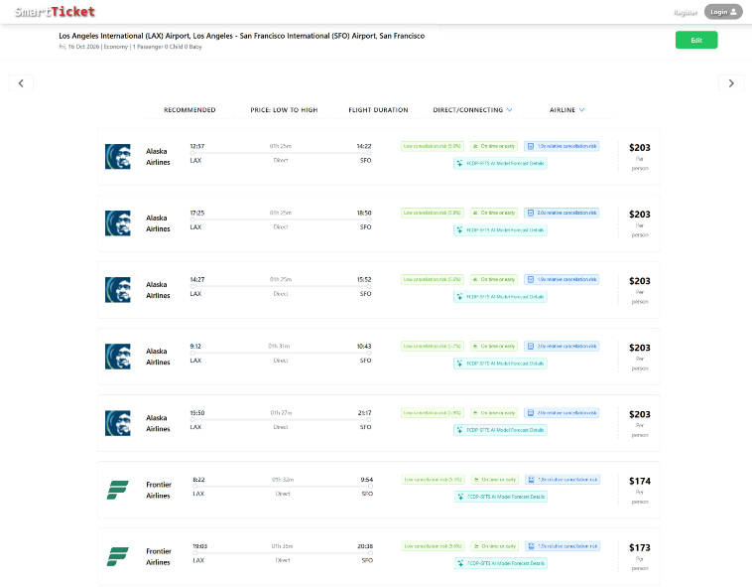
Fig. 19. Flight Tickets Listed in Search Result.
AI risk visualization: the cancellation probability, the four delay-class probabilities and the possible cause of a cancellation are shown with coloured bars and tags.
By clicking on the "FCDP-SFTS AI Model Forecast Details" label of a flight card, the user opens a detail panel. It shows the cancellation probability next to the average cancellation rate and the alert threshold, the delay-class probabilities, the cause probabilities conditional on a cancellation, the inputs that were actually available (observed weather, recent operational history) and any warnings. The panel states that the output is a risk indicator and not a forecast and gives the tested performance of the models. Figure 20 shows the detail panel for an example flight.
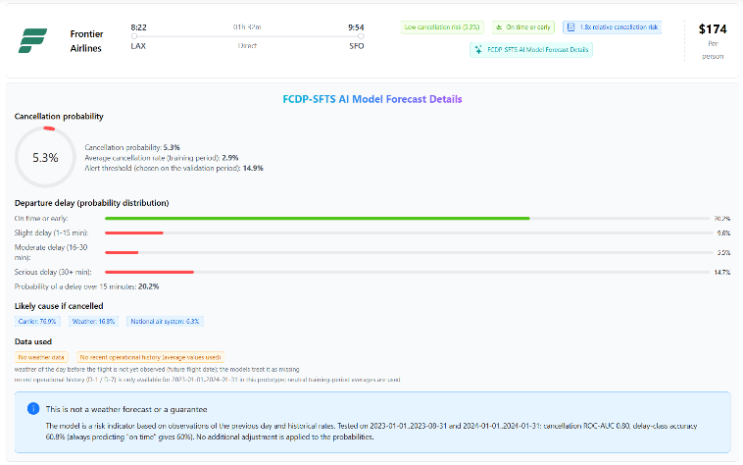
Fig. 20. AI model forecast details panel for a flight booked in advance (example flight from Los Angeles to San Francisco on 16 October 2026): the weather of the previous day has not yet been observed and the date lies outside the history table of the prototype, so these inputs are treated as missing or neutral and the panel shows the corresponding warnings.
Transparency: instead of a 'confidence score' (the largest class probability, which is not a measure of reliability), the interface shows the relative risk (probability divided by the average cancellation rate), the alert threshold chosen on the validation period and the evaluation results of the models.
With this system the technical applicability of the models in a ticket-search workflow was demonstrated. No usability or acceptance study has been performed, and no claim is made about the effect of the indications on passengers' decisions.
Figure 21 shows the overall system architecture of the website. User requests are routed from the frontend to the backend and from there to the model API; the results are returned in the same chain.
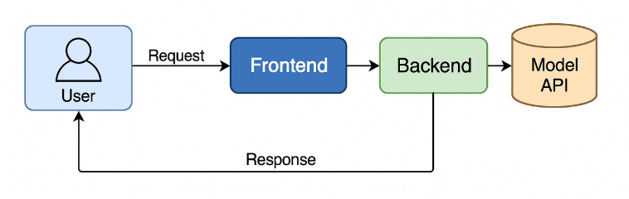
Fig. 21. SmartTicket System Architecture.
    - Prediction Output and Decision Threshold

The model API returns the probabilities of the models without post-processing. A cancellation alert is displayed when the cancellation probability reaches 0.149, the threshold that maximises F1 on the validation period (Mode A). This threshold balances precision and recall; it is not a statement about the costs of errors (see the relative-cost analysis in the Results section). Earlier prototype versions reduced the probabilities by hand-set factors of 30-70% (for summer months, daytime flights, short routes and large airlines) and used a threshold of 0.40 to 0.45. These adjustments have no empirical basis, invalidate the calibration of the probabilities, and were removed.

    - Interpretation of Errors

False alarms (a cancellation or a delay is indicated but does not occur) can cause needless worry and searches for alternative flights, while missed cancellations leave passengers uninformed. On the test period (Mode A, validation-selected threshold) the alert is raised for 3.0% of the flights; it captures 17.9% of the cancellations, and 16.9% of the alerts are correct. Most alerts are therefore false alarms, and the message shown to users must be phrased as a risk indication and not as a prediction that the flight will be cancelled.
For delays, the unweighted model rarely assigns the intermediate classes; the recall of delays beyond 30 minutes is 13.1% (Mode A), and the accuracy of 60.8% is only slightly above the 60.0% obtained by always predicting 'on time'. The probability of a delay beyond 15 minutes is therefore shown as a separate, more informative figure (ROC-AUC 0.693 on the test period). Statements about operational acceptability would require an evaluation with real users and airline partners, which has not been done.

    - Weather and History Inputs at Prediction Time

When a user selects a flight, the model API requests the daily weather observation of the previous calendar day for the origin and the destination airport from Meteostat station data (the same stations as in training); this is an observation, not a weather forecast. For flights whose previous day has not yet occurred - the usual case for tickets that are bought in advance - no observation exists; the weather inputs are then treated as missing and a warning is returned. The recent operational history (cancellation and delay rates of the previous day and week) is read from a lookup table that covers 2023-01-01 to 2024-01-31 in the prototype; for other dates, neutral training-period averages are used and a warning is displayed. Current information therefore enters the indication only for dates covered by the data; for all other dates the output is determined mainly by calendar, schedule, airline and route. The same-day operational state (Mode B), which improved the results in the experiments, would need a live operational data feed and is not implemented in the prototype. This is the usual situation for tickets bought in advance and the case shown in Figure 20.
SmartTicket shows how model-based risk indications can be connected to a ticket-search interface and how their limitations - missing inputs, performance in the test period, the difference between an indication and a forecast - can be communicated to the user. It makes no claim of operational benefits.
    - Technical Validation and Deployment Conditions

Technical validation: the model API is covered by automated tests. A parity test shows that the features built by the API reproduce the probabilities of the training pipeline for 300 test flights (maximum absolute difference below 1e-5); further tests cover the response schema, input validation (invalid dates, airports and times are rejected), determinism, the absence of post-hoc probability changes and the handling of unseen airlines and future dates. The parity test uncovered one deployment error: using all trees instead of the trees up to the early-stopping iteration changed probabilities by up to 0.12.
Response time was measured in-process (without network transport) with real Meteostat requests on a developer computer (30 requests): the median is 384 ms (95th percentile 424 ms) when the weather of an airport-day has to be downloaded, 76 ms (95th percentile 92 ms) with a warm cache, and 73 ms for future dates without weather retrieval. Loading the models takes about 3 s at start-up. The call to the external flight-search service, which dominates the end-to-end latency, is not included, and no load or scalability test was performed.
Security and deployment conditions: the prototype runs locally. The model API validates its inputs, limits the request size, restricts cross-origin requests to configured origins and can require a shared-secret header, which the back end sends with each prediction request. User registration and sign-in are handled by the back end (passwords stored as bcrypt hashes, JSON Web Tokens for sessions); the model API itself has no user authentication and no rate limiting. The keys of the external flight-search service, the token secrets and the shared secret are read from environment variables (.env files excluded from version control) and are not stored in the code. A production deployment would additionally need encrypted transport, rate limiting, key rotation, monitoring and versioning of the models, and a live data feed for the same-day mode.

Discussion and implications

This study evaluated three related prediction tasks - flight cancellation, cancellation cause and departure-delay class - with a leakage-controlled, chronologically validated protocol on 3.58 million U.S. domestic flights. The central finding is that these events are only moderately predictable from information available before departure: the models are useful as risk indicators, but they are far from the near-perfect accuracy that is sometimes reported for rare-event targets.
XGBoost was compared with logistic regression, a decision tree, a random forest and histogram-based gradient boosting. For cancellation and delay prediction the differences between algorithms were small compared with the effect of the information used, although this comparison was not symmetric (the other algorithms were untuned and used a 1-million-flight training subsample). For the cancellation cause, logistic regression exceeded XGBoost on the test period (76.0% and 77.4% against 70.7% and 73.9%) although it was worse on the validation period; selection followed the validation period, as required by the protocol, and the discrepancy shows how sensitive the cause task is to period-specific class distributions.
Cancellation prediction: PR-AUC 0.119 (Mode A) and 0.196 (Mode B) correspond to roughly 4 and 7 times the no-skill level, but precision at useful recall is low. The performance decreased from the validation to the test period and varies strongly between months. We attribute this to the episodic nature of cancellations (a few disruption days account for most cancellations), to differences in composition between the periods (the test period is dominated by one winter month with a complete, denser record), and to the limited number of events available for tuning. We cannot separate these effects with the present data. High accuracy values on a rare-event target are not informative by themselves: predicting 'not cancelled' for every flight already yields 97% accuracy.
Cancellation cause: the accuracy of 70.7% (Mode A) and 73.9% (Mode B) clearly exceeds the 60.2% majority baseline, mostly through the separation of carrier- and weather-caused cancellations. The national-air-system class is rarely recognised, and the distribution of causes drifts over time. Because the security class is almost exclusively a feature of 2020, it was excluded.
Departure delay: the four-class accuracy (60.8% and 61.9%) is only marginally above the majority baseline (60.0%), and the detection of intermediate classes fails. Class weighting raises the recall of long delays at a large cost in accuracy. For practical use, a binary or threshold-based formulation of 'delay beyond 15 minutes' (ROC-AUC 0.693-0.721) is more appropriate than the four-class output.
Implications: the ablation shows that recent operational history and, in Mode B, the same-day state carry most of the predictive information, whereas daily weather observed on the previous day adds little when this history is available. For passengers who book in advance, only Mode A is valid and its predictive value is modest; the day-of-departure mode needs a live operational data feed. The relative-cost analysis shows that alerts for cancellations pay off only when a missed cancellation is considerably more costly than a false alarm (cost ratios of about 10 or more); no monetary benefit is claimed. Methodologically, the study illustrates how leakage through resampling order, aggregate features and unrepresentative test periods can inflate performance.
Comparison with previous studies: the accuracies of up to 98% quoted in Sections 2 and 4.5.2 are much higher than the scores reported here, but they do not show that the present models are weaker, because several mechanisms can produce such values without corresponding predictive skill. First, accuracy on an imbalanced target is dominated by the majority class: in the present test period, predicting 'not cancelled' for every flight already gives 97.1% accuracy, and Yu et al. (2019) report about 90% accuracy for cancellation prediction together with an AUC of only 0.558. Second, balanced or resampled evaluation data change the meaning of accuracy: the cancellation task of Giarmas (2025) is balanced, so its reference level is 50% and not the 2-3% prevalence of operational data, and oversampling before the data are split places synthetic neighbours of test flights in the training data. Third, random or stratified splits put flights of the same disruption day into both the training and the test data; because cancellations cluster on a few days (Section 4.4.1), a model can learn the day itself, which a chronological split prevents. Fourth, inputs that are known only after departure, such as actual times, taxi times, delay-cause minutes or same-day weather aggregates, leak the outcome. Finally, several studies address a different target or scope, for example aggregate airport-level delays (Ye, Liu, Tian & Wan, 2020), booking cancellations (Ansari et al., 2019) or a single airport (Tang, 2021). In the data of this study, adding public files that contain only cancelled flights raises the share of cancelled flights to about 9% and can make the calendar year an almost perfect indicator of the label (Section 3). Because the protocols of the cited studies are not always reported, we cannot attribute their results to a specific mechanism; the comparison supports only the conclusion that accuracies obtained under different protocols are not comparable, and that the lower, leakage-controlled scores reported here are a more realistic estimate of the performance on future flights.
Limitations: (i) Data: the 2019-2023 records are a 3-million-flight sample and not the complete DOT data, and the test period contains no months from September to December 2023; the 2024 data are a single winter month and dominate the pooled test metrics. (ii) Weather: only daily observations of the previous day are used, not hourly observations or forecasts; the models cannot capture conditions at the time of departure. (iii) Geography and external validity: all data are U.S. domestic flights; results may not transfer to other regions. (iv) Class imbalance and rare classes remain a difficulty for the cause and delay models. (v) Possible residual leakage cannot be excluded entirely, although the history and same-day features are verified by automated tests and all fitted quantities use the training period only. (vi) Hyper-parameter search was limited, single-seed and, for delay, run on a subsample; comparison models were untuned. (vii) No deep-learning model was implemented or evaluated. (viii) The SmartTicket prototype has not been evaluated with users; its response time was measured only in-process on a developer computer, and no load, scalability or security testing was performed.
Future work: hourly weather observations and forecasts, calibration and uncertainty quantification of the probabilities, a live data feed for Mode B, evaluation of deep sequence models (for example LSTM or GRU), a multi-seed and multi-year validation including all seasons, and a user study of the prototype. These items are planned and have not been implemented.

Conclusion and future work

Conclusion. We built three XGBoost-based models for flight cancellation, cancellation cause and departure-delay class and evaluated them with a leakage-controlled chronological protocol. Implemented and experimentally evaluated: the reconstructed data set, D-1 weather features, history and same-day features, ablations, SHAP explanations, a comparison with four other algorithms, a relative-cost analysis and monthly stability. The results show moderate predictability: cancellation PR-AUC 0.119-0.196 (no-skill 0.029), cause accuracy 70.7%-73.9% (baseline 60.2%), and four-class delay accuracy 60.8%-61.9% (baseline 60.0%). Implemented but not evaluated: the SmartTicket web prototype, which presents the predictions to users. Planned and not implemented: real-time and hourly weather and forecast integration, deep sequence models, a user study, the proposed quarterly retraining cycle, and validation on additional years and regions. These distinctions should be kept in mind when reading the claims made for the system.

Data availability
The flight data used in this study are publicly available on Kaggle (Zelaya, 2023; Singh, 2024), and the weather observations are available from Meteostat (Meteostat, 2024). The code that rebuilds the data set from these sources, the scripts that reproduce all experiments, tables and figures, the trained models and the SmartTicket prototype are available at https://github.com/nuricanbrdmr/flight-delay-and-cancellation-prediction-system.

References

Li, N., & Yao, H. G. (2025). A review of research on flight delay propagation: Current situation and prospect. Journal of Advanced Transportation, 2025(1), Article 4851103. https://doi.org/10.1155/atr/4851103
Çalış, A., Durmaz, K. İ., & Gencer, C. (2018). Uçak seferlerindeki rötarları etkileyen faktörlerin analizi [Analysis of the factors affecting the flight delays]. Uluslararası İktisadi ve İdari İncelemeler Dergisi, (20), 179–190. https://doi.org/10.18092/ulikidince.353973
U.S. Department of Transportation. (2024, March 1). Air travel consumer report: December 2023, full year 2023 numbers. https://www.transportation.gov/briefing-room/air-travel-consumer-report-december-2023-full-year-2023-numbers
AirHelp. (2024). Over 45 million UK passengers faced disruptions in 2023. https://www.airhelp.com/en-int/press/airhelp-reveals-that-over-45-million-uk-passengers-faced-disruptions-in-2023/
Civil Aviation Authority. (2024). 2023 annual punctuality statistics: Summary analysis [Data set]. https://www.caa.co.uk/data-and-analysis/uk-aviation-market/flight-punctuality/uk-flight-punctuality-statistics/2023
L'Heureux, A., Grolinger, K., Elyamany, H. F., & Capretz, M. A. M. (2017). Machine learning with big data: Challenges and approaches. IEEE Access, 5, 7776–7797. https://doi.org/10.1109/ACCESS.2017.2696365
Bentéjac, C., Csörgő, A., & Martínez-Muñoz, G. (2021). A comparative analysis of gradient boosting algorithms. Artificial Intelligence Review, 54(3), 1937–1967. https://doi.org/10.1007/s10462-020-09896-5
Dumitrascu, B., & Aiordachioaie, D. (2022). On data preprocessing for an improved performance of the sources classification. In 2022 IEEE 28th International Symposium for Design and Technology in Electronic Packaging (SIITME) (pp. 61–64). https://doi.org/10.1109/SIITME56728.2022.9988325
Sternberg, A., Soares, J., Carvalho, D., & Ogasawara, E. (2017). A review on flight delay prediction. arXiv preprint, arXiv:1703.06118.
Chawla, N. V., Bowyer, K. W., Hall, L. O., & Kegelmeyer, W. P. (2002). SMOTE: Synthetic minority over-sampling technique. Journal of Artificial Intelligence Research, 16, 321–357. https://doi.org/10.1613/jair.953
Khaksar, H., & Sheikholeslami, A. (2019). Airline delay prediction by machine learning algorithms. Scientia Iranica, Transactions A: Civil Engineering, 26(5), 2689-2702. https://doi.org/10.24200/sci.2017.20020
Ye, B., Liu, B., Tian, Y., & Wan, L. (2020). A methodology for predicting aggregate flight departure delays in airports based on supervised learning. Sustainability, 12(7), 2749. https://doi.org/10.3390/su12072749
Atlıoğlu, M. C., Bolat, M., Şahin, M., Tunalı, V., & Kılınç, D. (2020). Supervised learning approaches to flight delay prediction. Sakarya University Journal of Science, 24(6), 1223-1231. https://doi.org/10.16984/saufenbilder.710107
Mohamed, H. M., Al-Tabbakh, S. M., & El-Zahed, H. (2018). Machine learning techniques for analysis of Egyptian flight delay. Journal of Scientific Research in Science, 35(1), 390-399. https://doi.org/10.21608/jsrs.2018.25523
Kurt, M. (2019). Flight delay prediction [Master's project, MEF University, Graduate School of Science and Engineering].
Tang, Y. (2021). Airline flight delay prediction using machine learning models. In 2021 5th International Conference on E-Business and Internet (pp. 151-154). https://doi.org/10.1145/3497701.3497725
Zelaya, P. (2023). Flight delay and cancellation dataset (2019–2023) [Dataset]. Kaggle. https://www.kaggle.com/datasets/patrickzel/flight-delay-and-cancellation-dataset-2019-2023
Singh, S. (2024). Flight delay dataset (2018–2024) [Dataset]. Kaggle. https://www.kaggle.com/datasets/shubhamsingh42/flight-delay-dataset-2018-2024
Ayodele, T. O. (2010). Types of machine learning algorithms. In Y. Zhang (Ed.), New advances in machine learning (Chapter 3). InTech. https://doi.org/10.5772/9385
Breiman, L., Friedman, J. H., Olshen, R. A., & Stone, C. J. (1984). Classification and regression trees. Wadsworth & Brooks/Cole.
Ke, G., Meng, Q., Finley, T., Wang, T., Chen, W., Ma, W., Ye, Q., & Liu, T.-Y. (2017). LightGBM: A highly efficient gradient boosting decision tree. In Advances in Neural Information Processing Systems 30 (NIPS 2017) (pp. 3146-3154).
Breiman, L. (2001). Random forests. Machine Learning, 45(1), 5–32. https://doi.org/10.1023/A:1010933404324
Schultz, M., Reitmann, S., & Alam, S. (2021). Predictive classification and understanding of weather impact on airport performance through machine learning. Transportation Research Part C: Emerging Technologies, 131, 103119. https://doi.org/10.1016/j.trc.2021.103119
Chen, T., & Guestrin, C. (2016). XGBoost: A scalable tree boosting system. In Proceedings of the 22nd ACM SIGKDD International Conference on Knowledge Discovery and Data Mining (pp. 785–794). https://doi.org/10.1145/2939672.2939785
Yu, Y., Mo, H., & Li, H. (2019). A classification prediction analysis of flight cancellation based on Spark. In 7th International Conference on Information Technology and Quantitative Management (ITQM 2019), Procedia Computer Science, 162, 480–486. https://doi.org/10.1016/j.procs.2019.12.014
Giarmas, N. (2025). Flight delay and cancellation prediction, using machine learning models [Diploma thesis, University of Macedonia, Thessaloniki].
Ansari, A., Shaikh, A., Mapkar, S., & Khan, M. (2019). Cancellation prediction for flight data using machine learning. In 2nd International Conference on Advances in Science & Technology (ICAST-2019). SSRN. https://papers.ssrn.com/sol3/papers.cfm?abstract_id=3367683
Alfarhood, M., Alotaibi, R., Abdulrahim, B., Einieh, A., Almousa, M., & Alkhanifer, A. (2024). Predicting flight delays with machine learning: A case study from Saudi Arabian Airlines. International Journal of Aerospace Engineering, 2024, 1–11. https://doi.org/10.1155/2024/3385463
Hake, P. S., Parjane, P. P., Parte, S. S., Subhedar, L. S., & Dimble, N. (2025). Aero Predict & Flight Booking. Iconic Research and Engineering Journals, 8(12), 106-111.
Barua, B., & Kaiser, M. S. (2024). A next-generation approach to airline reservations: Integrating cloud microservices with AI and blockchain for enhanced operational performance. arXiv preprint, arXiv:2411.06538. https://doi.org/10.48550/arXiv.2411.06538
Lambelho, M., Mitici, M., Pickup, S., & Marsden, A. (2020). Assessing strategic flight schedules at an airport using machine learning-based flight delay and cancellation predictions. Journal of Air Transport Management, 82, 101737. https://doi.org/10.1016/j.jairtraman.2019.101737
Khan, W. A., Chung, S.-H., Eltoukhy, A. E. E., & Khurshid, F. (2024). A novel parallel series data-driven model for IATA-coded flight delays prediction and features analysis. Journal of Air Transport Management, 114, 102488. https://doi.org/10.1016/j.jairtraman.2023.102488
Truong, D. (2021). Using causal machine learning for predicting the risk of flight delays in air transportation. Journal of Air Transport Management, 91, 101993. https://doi.org/10.1016/j.jairtraman.2020.101993
Li, Q., Guan, X., & Liu, J. (2023). A CNN-LSTM framework for flight delay prediction. Expert Systems with Applications, 227, 120287. https://doi.org/10.1016/j.eswa.2023.120287
Gama, J., Žliobaitė, I., Bifet, A., Pechenizkiy, M., & Bouchachia, A. (2014). A survey on concept drift adaptation. ACM Computing Surveys, 46(4), 1–37. https://doi.org/10.1145/2523813
He, H., & Garcia, E. A. (2009). Learning from imbalanced data. IEEE Transactions on Knowledge and Data Engineering, 21(9), 1263-1284. https://doi.org/10.1109/TKDE.2008.239
Elkan, C. (2001). The foundations of cost-sensitive learning. In International Joint Conference on Artificial Intelligence (Vol. 17, No. 1, pp. 973-978). Lawrence Erlbaum Associates Ltd.
Lu, J., Liu, A., Dong, F., Gu, F., Gama, J., & Zhang, G. (2019). Learning under concept drift: A review. IEEE Transactions on Knowledge and Data Engineering, 31(12), 2346-2363. https://doi.org/10.1109/TKDE.2018.2876857
Cerqueira, V., Torgo, L., & Mozetič, I. (2020). Evaluating time series forecasting models: An empirical study on performance estimation methods. Machine Learning, 109(11), 1997-2028. https://doi.org/10.1007/s10994-020-05910-7
Pedregosa, F., Varoquaux, G., Gramfort, A., Michel, V., Thirion, B., Grisel, O., et al. (2011). Scikit-learn: Machine learning in Python. Journal of Machine Learning Research, 12, 2825-2830.
Lundberg, S. M., & Lee, S.-I. (2017). A unified approach to interpreting model predictions. In Advances in Neural Information Processing Systems 30 (NIPS 2017) (pp. 4765-4774).
Saito, T., & Rehmsmeier, M. (2015). The precision-recall plot is more informative than the ROC plot when evaluating binary classifiers on imbalanced datasets. PLoS ONE, 10(3), e0118432. https://doi.org/10.1371/journal.pone.0118432
Bergstra, J., & Bengio, Y. (2012). Random search for hyper-parameter optimization. Journal of Machine Learning Research, 13, 281-305.
O'Brien, R. M. (2007). A caution regarding rules of thumb for variance inflation factors. Quality & Quantity, 41(5), 673-690. https://doi.org/10.1007/s11135-006-9018-6
Meteostat. (2024). Meteostat: Open weather and climate data and Python library. https://meteostat.net

